Infinite and Procedural Terrain Generation:

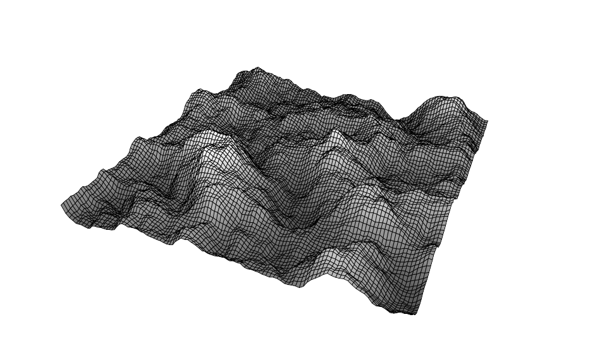



by JAMES MULLINEUX

Student ID: 794796

Supervisor: Dr Sud Sudirman

Programme: BSc Computer Games Development

Liverpool John Moores University

6100COMP, Software Development Project

Submitted on 22nd May 2020

# Preliminaries

## Abstract

Procedural generation techniques and procedural terrain generation are used extensively in modern games, this project will explore the impact of procedural terrain generation on a game as well as document the development process of generating and rendering procedural 3D terrain.

Additionally, there will be a further special focus on infinite terrain. The project will explore the techniques behind implementing infinite terrain, as well as documenting the development process of integrating an infinite terrain system with procedurally generated 3D terrain.

## Dedication

Dedicated to my father, James Michael Ratcliffe, who suddenly passed away during my time at LJMU; honouring his memory encourages me to succeed in everything I do.

## Acknowledgments

I thank my supervisor, Dr Sud Sudirman, for aiding me in completion of this project and providing feedback to help me improve.

I also would like to thank Dr Chris Carter, an extremely gifted developer and senior lecturer and teacher at LJMU who helped me generate ideas for the project, as well as referring me to my supervisor.

Table of Contents

Preliminaries 2

Abstract 2

Dedication 3

Acknowledgments 4

Table of Figures 8

Chapter 1: Introduction 11

1.1 What is Procedural Terrain Generation? 11

1.2 What Problems will the Project Tackle? 11

1.3 How is this Project Original and why is it Important? 11

1.4 Project Aim/Expected Final Result 12

1.5 Project Objectives/Goals 12

1.5.1 Unity and C# 12

1.5.2 Generating Perlin Noise and Rendering Noise Maps 12

1.5.3 Complex Noise Map Control 12

1.5.4 Generating and Rendering a Colour Map 12

1.5.5 Complex Colour Map Control 12

1.5.6 Rendering a Textured 3D Mesh 12

1.5.7 Implementing an Endless Terrain System 12

1.6 Project Motivation 13

1.7 Methodology 13

1.8 What were the results? High level Overview 13

Chapter 2: Background and Literature Survey/Technical Research 14

2.1 Literature Review 14

2.1.1 Examples of procedural generation in games 14

2.1.2 Examples of procedural terrain in games 14

2.1.3 Examples of infinite terrain in games 14

2.1.4 Noise algorithms 14

2.2 Technical Research 14

2.2.1 Unity Game Engine (Language and Support available for procedural generation) 15

2.2.2 C# 15

2.2.3 Integrated Development Environment (IDE) 15

2.2.4 Trello 15

2.2.5 Unreal Landscaping Tools 15

2.2.6 World Machine 15

Chapter 3: Problem Analysis 16

3.1 Problem Breakdown 16

3.2 Project Management 17

3.2.1 Project Deadlines & Gantt Chart 17

3.2.2 Tracking Progress (Trello) 17

3.3 Development of Aims 18

3.3.1 What is Perlin Noise? 18

3.3.2 Noise Maps, Amplitude and Frequency 19

3.3.3 Octaves, Lacunarity and Persistence 19

3.3.4 Generating and Rendering a 3D Mesh 20

3.3.5 Improving Performance: Levels of Detail (LOD) 20

3.3.6 Improving Performance: Mesh Chunks 21

Chapter 4: Design / Development / Solution 22

4.1 Project Setup 22

4.2 Generating and Rendering a Perlin Noise Map 22

4.2.1 Generating a noise map: Noise.cs 22

4.2.2 Rendering the noise map: MapGenerator.cs and MapDisplay.cs 24

4.2.3 Rendering the noise map: Map Material and Editor Script 26

4.3 Greater Perlin noise map control 28

4.3.1 Octaves, Persistence and Lacunarity 28

4.3.2 Seed 31

4.3.3 Noise Scale and OnValidate 32

4.4 Colour Maps 32

4.4.1 Creating Regions and assigning Colours to Height Values 32

4.4.2 Draw Mode: Nosie Map and Colour Map 33

4.4.3 TextureGenerator.cs 34

4.4.4 Colour Map Final Result 35

4.5 3D Mesh 37

4.5.1 MeshGenerator.cs: Vertices, Triangles 37

4.5.2 UV Maps 38

4.5.3 Rendering the Mesh 39

4.6 Height Multiplier and Height Curve 40

4.6.1 Height Multiplier 40

4.6.2 Height Curve 42

4.7 Level of Detail (LOD) 44

4.8 Endless Terrain System: Viewer and Terrain Chunks 46

4.9 Endless Terrain System: Map & Mesh Integration and Threading 50

4.10 Endless Terrain System: Level of Detail Implementation 53

4.11 Endless Terrain System: Textures and Mesh Offset 54

4.12 Seams 55

Chapter 5: Evaluation 58

5.1 Test Plan 58

5.2 Objectives Completed? Aim Accomplished? 60

5.3 Project Strengths and Significance 60

5.3.1 Project Management 60

5.3.2 Project Difficulty and Learning 60

5.4 Project Weaknesses 60

Chapter 6: Conclusions & Further Work 61

References & Bibliography 62

Appendices 63

Application Code 63

Noise.cs 63

MapGenerator.cs 64

MeshGenerator.cs 67

MapDisplay.cs 68

TextureGenerator.cs 69

EndlessTerrain.cs 70

FalloffGenerator.cs 73

Monthly Reports 74

November Supervision Meeting Report 74

December Supervision Meeting Report 75

January Supervision Meeting Report 76

February Supervision Meeting Report 77

March Supervision Meeting Report 78

April Supervision Meeting Report 79

Ethics Application and Approval Documentation 80

## Table of Figures

Figure 1: A Gantt chart showing initial tasks and deadlines 17

Figure 2: Trello board showing how project progress is tracked 17

Figure 3: Regular noise map 18

Figure 4: Perlin noise map 18

Figure 5: Visual axis representation of an octave 18

Figure 6: 3 octaves (blue) and their result when added (red) 19

Figure 7: An array of points from 0 to 8 20

Figure 8: An array of points being incremented by 2 20

Figure 9: An array of points being incremented by 4 20

Figure 10: An error occurring from an array of 9 points being incremented by 3 21

Figure 11: Noise.cs script as seen from the Unity editor 22

Figure 12: GenerateNoiseMap method with 3 arguments 22

Figure 13: Creation of a 2D array called "noiseMap" 22

Figure 14: A for loop to find x and y sample coordinates and the Perlin Value 22

Figure 15: If statement to clamp the scale value 23

Figure 16: Perlin value calculated and noise map returned 23

Figure 17: Initial code for the Noise class 23

Figure 18: MapGenerator.cs and MapDisplay.cs as seen from the Unity editor 24

Figure 19: Map Generator object in the Unity scene hierarchy 24

Figure 20: MapGenerator.cs applied to Map Generator object 24

Figure 21: Declaration of mapWidth, mapHeight and noiseScale variables 24

Figure 22: DrawNoiseMap method to calculate width and height of noise map 24

Figure 23: Texture created with width and height of noise map 25

Figure 24: For loop to assign pixel colours 25

Figure 25: Shared material texture set 25

Figure 26: Initial draft of MapDisplay.cs 25

Figure 27: Reference to map display inside MapGenerator.cs 25

Figure 28: Map material as seen in the Unity editor 26

Figure 29: Editor script and GUI override 26

Figure 30: Initial Perlin noise map being rendered to screen 26

Figure 31: Map Width, Map Height, Noise Scale and Auto Update options in Unity editor 27

Figure 32: GenerateNoiseMap method with seed, scale, octaves, persistance and lacunarity arguments added 28

Figure 33: Declaration of amplitude, frequency and noiseHeight variables 28

Figure 34: Octaves loop with scale and frequency applied; variable values calculated 28

Figure 35: noiseHeight applied to noiseMap 28

Figure 36: maxNoiseHeight and minNoiseHeight variables declared 29

Figure 37: If and else statement to track min and max noise height 29

Figure 38: noiseMap being normalised 29

Figure 39: New Perlin noise map rendered with additional variables/parameters 30

Figure 40: Pseudo Random Number Generator 30

Figure 41: prng and offsets added to octaves loop 30

Figure 42: offsets added to sample coordinated 31

Figure 43: Seed and Offset variables as seen in the Unity editor 31

Figure 44: halfWidth and halfHeight declared and subtracted from the sample coordinates 31

Figure 45: mapWidth, mapHeight, lacunarity and octaves variables clamped by OnValidate method 31

Figure 46: TerrainType struct with name, height and colour variables 32

Figure 47: Colour map generated 32

Figure 48: DrawMode enum declared and added to map display 33

Figure 49: TextureGenerator.cs script as seen in the Unity editor 33

Figure 50: TextureFromColourMap method 33

Figure 51: TextureFromHeightMap method 33

Figure 52: DrawTexture method with colour map changes 34

Figure 53: The Draw Mode option as seen in the Unity editor 35

Figure 54: Colour map rendered with 2 regions defined by the user 35

Figure 55: Colour map rendered with 8 regions defined by the user 35

Figure 56: MeshGenerator.cs script as seen in the Unity editor 36

Figure 57: Vector3 vertices and int triangles 36

Figure 58: MeshData method with meshWidth and meshHeight arguments 36

Figure 59: AddTriangle method to add triangles 36

Figure 60: For loop to increment vertices 36

Figure 61: UV array implemented into MeshData 37

Figure 62: For loop to tell each vertex position as percentage 37

Figure 63: Mesh DrawMode 38

Figure 64: meshRenderer and meshFilter references 38

Figure 65: Empty Mesh object in Unity editor 38

Figure 66: Mesh Material as seen in the Unity editor 38

Figure 67: Map Display script in the Unity editor with the Mesh Filter and Mesh Renderer assigned 38

Figure 68: Flat 3D mesh generated and rendered 39

Figure 69: heightMultiplier implemented into MeshGenerator 39

Figure 70: meshHeightMultiplier passed as parameter to the terrain mesh call 39

Figure 71: 3D Terrain Mesh with heightMultiplier implemented 40

Figure 72: Mesh Height Curve 41

Figure 73: Mesh Height Curve with key added 41

Figure 74: meshHeightCurve added to DrawMesh and GenerateTerrainMesh 41

Figure 75: Corresponding height map values from height curve 41

Figure 76: 3D Terrain Rendered with height curve implemented 42

Figure 77: mapChunkSize and levelOfDetail variables declared 43

Figure 78: levelOfDetail variable passed into GenerateTerrainMesh method 43

Figure 79: levelOfDetail variable added as argument to GenerateTerrainMesh method 43

Figure 80: meshSimplificationIncrement declared 43

Figure 81: Number of vertices per line calculated 43

Figure 82: 3D Terrain rendered at highest LOD 44

Figure 83: Same mesh as Figure 82 with a simpler LOD 44

Figure 84: EndlessTerrain.cs script as seen in the Unity editor 45

Figure 85: maxViewDst, Transform viewer, Vector2 viewerPosition, chunkSize and chunksVisibleInViewDst variables declared 45

Figure 86: Start method to fetch the chunk size from MapGenerator.cs 45

Figure 87: for loop to store x and y coordinates of chunks surrounding the viewer 45

Figure 88: Dictionary to store coordinates and terrain chunks 45

Figure 89: if and else statement to handle cases for when the dictionary contains the key for a viewed chunk 46

Figure 90: TerrainChunk class created 46

Figure 91: TerrainChunk constructor 46

Figure 92: Vector 2 position declared 46

Figure 93: Vector3 position 46

Figure 94: 2D Plane game object substantiated 46

Figure 95: bounds struct declared 47

Figure 96: UpdateTerrainChunk method 47

Figure 97: SetVisible method 47

Figure 98: Update method 47

Figure 99: EndlessTerrain.cs script added to MapGenerator object; viewer object added to scene 47

Figure 100: Chunks being generated around viewer 48

Figure 101: Rendered chunks dynamically updating as the viewer moves along the x axis 48

Figure 102: Rendered chunks dynamically updating as the viewer moves along the z axis 48

Figure 103: DrawMap code moved to new method called DrawMapInEditor 49

Figure 104: RequestMapData and OnMapDataReceived methods for threading 49

Figure 105: MapDataThread method to set up queue 50

Figure 106: Update method to handle thread queue 50

Figure 107: Threading technique being used for mesh data 50

Figure 108: Chunks being rendered as terrain meshes 51

Figure 109: Terrain mesh chunks dynamically rendering around viewer 51

Figure 110: Terrain mesh chunks updating dynamically as the viewer moves 51

Figure 111: LODMesh class 52

Figure 112: Shaded Wireframe view to show chunks further from the viewer with less triangle and vertices 52

Figure 113: Texture created and applied to material when map data is received 53

Figure 114: Endless Terrain rendered with textures 53

Figure 115: Terrain chunks with seams NOT aligned 54

Figure 116: Octaves loop affected by offsets 54

Figure 117: Terrain chunk seams aligned but gap still visible 54

Figure 118: Noise class with NormalizeMode enum 55

Figure 119: if and else statement to handle cases for each normalise mode 55

Figure 120: maxPossibleHeight variable declared 55

Figure 121: maxPossibleHeight calculated in octaves loop 56

Figure 122: normalized height calculated 56

Figure 123: Seamless Procedurally Generated Infinite Terrain 56

# Chapter 1: Introduction

## 1.1 What is Procedural Terrain Generation?

When a developer wishes to use 3D terrain within their game, they have 2 options; they can either manually sculpt the terrain using tools such as Unreal Engine’s landscaping tools or they can procedurally generate the terrain based on a number of parameters. Manually sculpting and painting terrain is a perfectly valid method, and is actually the preferred method for creating terrain that is on a small scale. However, if a game is larger in scale and will feature a large landscape; procedurally generating terrain is definitely the preferred method. By procedurally generating terrain, developers can reduce develop time significantly and often end with a result of much higher quality than if the entire terrain was sculpted manually. Procedural terrain generation can also be used when a developer wants to have a different terrain every time the game is played.

## 1.2 What Problems will the Project Tackle?

I have always wondered; how do developers create games that allow the player to generate seemingly infinite varieties of worlds. Games such as; Don’t Starve, RimWorld, Spelunky, Spore, Terraria and many, many others are all extremely popular and well received, and this due in large part to the fact that when a world is generated, it is generated procedurally. Every time the player generates a world, it is different. The player is guaranteed to have a different experience every time they play.

The main aim of my project is to set out and research the many different approaches to implementing procedurally generated terrain; I want to discover what tools are available to allow developers to implement such a powerful feature into their games. I also want to take this research and apply it by creating a software product that allows the developer/user to generate their own procedurally generated terrain, with the ability to alter features of the terrain.

Through preliminary research, I have decided to implement my procedural terrain (develop my software) using Unity and C#. The engine and language used by my course is Unreal Engine and C++, and whilst it is true I would likely have an easier time using these tools; I have decided to use Unity and C# to test my ability to adapt. Unity and C# are widely used in the gaming industry, so I want to show that I can independently learn essential skills and tools.

To further push myself, I will also attempt to implement infinite terrain generation. Many games not only use procedurally generated terrain, but the terrain will also expand infinitely as the player explores. The most popular example of this is Minecraft, and it can be argued that its infinite procedurally generated terrain is what makes it the most popular game to ever exist. I will have to do significant research to tackle these problems, this report will document that research and will also document my development process.

## 1.3 How is this Project Original and why is it Important?

The originality of this project comes from its difficulty and the fact that I am a complete novice in the field of procedural terrain generation, beyond the facts of knowing what procedural terrain generation is and why it’s used; I have no idea how this technique is actually programmed and implemented, at least as of the start of the project timeline; this will no longer be true by the end of the project. If the project doesn’t sound challenging enough, I will also be developing the project/software product entirely using Unity and C#; these are tools I have no experience with so it will be necessary for me to become familiar with these tools before development can begin

## 1.4 Project Aim/Expected Final Result

My project aim defines the ultimate aim of the project. The aim is to develop a software product, using Unity and C#, that allows the user to generate an infinite landscape; this landscape will be procedurally generated and feature textured regions such as mountains, hills, grass, beaches, water, etc. Using the Unity editor the user will be able to manipulate the terrain by changing a number of parameters. The Unity project will also feature a viewer object, by moving this viewer object terrain chunks will dynamically render to facilitate an endless terrain system. Along with my software product, I will also document my research and development process in this report, as well as providing a presentation with speaker notes.

## 1.5 Project Objectives/Goals

My project objectives all serve to help me achieve the project aim. For my project to be considered a success, and for my project aim to be achieved; each of these objectives must be complete. Near the end of the project timeline, a number of tests will be conducted to ensure every single objective has been accomplished. These objectives are derived from preliminary research and will likely be updated as unexpected problems arise.

### 1.5.1 Unity and C#

I am a complete novice with no experience using the Unity game engine and C# programming language, this is because my course uses the Unreal game engine and C++ programming language for development. Whilst it would be possible, and likely easier for myself, to develop this project using Unreal and C++; I am making it an object to develop the entire project using Unity and C#. Unity and C# are extremely important tools in the game development industry, and this project is the perfect opportunity to significantly improve my skill set and employability.

### 1.5.2 Generating Perlin Noise and Rendering Noise Maps

The first objective for developing the Unity project will be to generate a noise map using Perlin noise. This noise map is used to process the terrain parameters (amplitude, frequency, etc.) and upon which the colour map, 3D mesh and endless terrain will be created. The noise map will also be rendered to the screen as a texture, to serve as a visual representation of the noise.

### 1.5.3 Complex Noise Map Control

To allow for more complex terrain a number of variables/parameters will be used when generating the noise map, such as; octaves, lacunarity, persistence, noise scale, etc. Each of these variables will be editable from the Unity editor, this is to allow the user to manipulate the shape and structure of the terrain.

### 1.5.4 Generating and Rendering a Colour Map

Using the Perlin noise map, a colour map will be generated and rendered to the screen. This colour map will allow the user to visualise the terrain on a 2D plane, rather than just 3D. The colour map will feature regions that represent the different terrain features; mountain, grass, water, etc.

### 1.5.5 Complex Colour Map Control

Through the Unity editor, the user will be able to customise the regions by assigning a colour, naming the region, deciding how prominent the region is and adding/removing regions.

### 1.5.6 Rendering a Textured 3D Mesh

Using the Perlin noise map and a height map; the Unity project will render a 3D mesh. The noise map will be used to decide the shape and structure of the mesh, whilst the colour map will be used too apply an appropriate texture to the mesh.

### 1.5.7 Implementing an Endless Terrain System

By using a terrain chunks technique, an endless terrain system will be implemented. This will allow the user to explore a seemingly infinite continuous terrain mesh using a viewer object, the terrain chunks will dynamically render as the viewer moves. A number of techniques, such as the chunks system and threading, will be used to improve performance.

## 1.6 Project Motivation

I’ve learnt a lot during my time at university, but there’s always more to learn and I wanted to ensure I would learn a lot throughout this project, as such I chose an area that I was very much unfamiliar with. However, my project needed to be both interesting and useful too; so I thought about which games I enjoyed most and realised games I enjoyed most were games with large amounts of replay-ability. This replay-ability comes from impressive procedural generation; these techniques allow for a very different experience each time you play. Also, the fact that so many of the greatest games make use of procedural generation further proved to me that this would be a worthwhile endeavour.

My motivation for choosing to develop my project with Unity and C# is that it’s a great way to push myself further, I had very little experience with this engine and language but they are used widely in the games development industry so learning both would be invaluable experience for me.

## 1.7 Methodology

Throughout this project I will utilise an agile development approach, specifically the Scrum methodology. This approach to development focuses on delivering results incrementally, instead of all at once. Using the monthly supervisor meetings and Trello (an online Kanban-style application used for managing projects) I will outline a backlog, a list of tasks to complete, and a list of completed tasks, every month. Each month I will complete any assigned tasks, focusing on those of higher priority first. This will ensure I am extremely organised and allows me and my supervisor to be fully aware of how far along I am and how well I am progressing.

## 1.8 What were the results? High level Overview

My project was a resounding success, by setting deadlines that I adhered to and utilising an agile development approach I managed to complete all my objectives (and more) and achieve my project aim fully. This isn’t to say that the project couldn’t be expanded however, as I discuss later in this report.

# Chapter 2: Background and Literature Survey/Technical Research

## 2.1 Literature Review

The topic addressed in this report is terrain rendering, with a specific focus on procedural terrain generation (it’s problems and solutions), so I have accumulated background information and research relating to this. This research will help develop understanding of the area, as such to help me develop my own project.

### 2.1.1 Examples of procedural generation in games

One of my first thoughts was how extensively are procedural techniques used in games, are these techniques used extensively and how are they used? I found that procedural techniques are used extensively in games, there is even an entire genre of games dedicated to procedural content generation; “Roguelike” games; these are games that have players explore and fight through procedurally generated levels.

Procedurally generated content has been used in games as early as the 1970’s, games such as; Beneath Apple Manor (1978), Maze Craze (1978), Rogue (1980) and Sword of Fargoal (1982). Games such as these are considered the founding fathers of Roguelike games; a game genre dedicated to procedurally generated content.

Procedural generation is also used extensively in modern games, and is often the cornerstone feature of some of the most popular games ever created. Such as; the Civilization games series (since 1991), Don’t Starve (2013), The Binding of Isaac (2011), the Diablo games series (since 1996), Minecraft (2009) and many, many others. All of these games use procedural generation to generate content; such as levels and terrain. Minecraft is the best-selling video game to date, and there is no doubt this is because of its extensive replay-ability; due to its procedurally generated infinitely large game worlds.

### 2.1.2 Examples of procedural terrain in games

Whilst many games use procedural generation techniques, not all of them procedurally generate terrain. Games such as Spore and Don’t Starve do though. These games procedurally generate their terrain not just to save time, but as a gameplay mechanic. Every time a world is created it is different, this means that every time the player plays the game they will have a different experience; this is a large contributing factor to these games’ success.

### 2.1.3 Examples of infinite terrain in games

Perhaps the most famous example of an infinite terrain system is Minecraft (2009). Minecraft has sold “176 million units since its release in 2011” (Statista, 2020), this makes it the best-selling game of all time. The greatest appeal of the game is that it allows players to explore and build within an infinitely large procedural world.

### 2.1.4 Noise algorithms

A noise algorithm is “a function that maps every n-dimensional vector to a deterministic, but seemingly random real number” (Sepp, 2015). Noise algorithms are used to generate height maps, from which 2D and 3D terrain can be generated. For this project, Perlin noise (a type of gradient noise) will be used. Other noise algorithms do exist however, such as Simplex noise. Simplex noise is “a noise without directional artefacts” (Patricio Gonzale Vivo) and “an algorithm that is easy to implement in hardware” (Patricio Gonzale Vivo); it is a method for creating an n-dimensional noise function.

## 2.2 Technical Research

A number of software tools currently exist to generate terrain both manually and procedurally, exploring these tools and their features will help me better understand how I should develop my own software product. I will also explore the tools that will be used to develop the project.

### 2.2.1 Unity Game Engine (Language and Support available for procedural generation)

This project has been developed using Unity. Unity is a “*real-time 3D development platform*” (Unity Technologies, 2020), it is a widely used game engine and as such there is a large amount of learning resources available for developers of all experience levels. It is a free resource that anyone can use, and it allows the developer using it to publish games using the engine; with royalties being paid to Unity if the game reaches a certain revenue milestone. Paid licences do exist to access additional features and remove the royalties fee, but this isn’t necessary for this project.

### 2.2.2 C#

C# is a programming language, and the language used by the Unity game engine. C# is a very popular programming language and as such a vast amount of learning resources are available. Learning Resources such as W3Schools (Refsnes Data, 2020), C# in Depth (Skeet, 2008) and C# Tutorial – Full Course for Beginners (freeCodeCamp.org, 2018) are crucial in my journey to learn C#.

### 2.2.3 Integrated Development Environment (IDE)

For this project, Microsoft Visual Studio 2013 is used; but theoretically any IDE that supports Unity and C# development could be used. These include; Visual Studio Code, JetBrains Rider and Xcode.

### 2.2.4 Trello

Trello is a web-based Kanban-style list-making application, it is great for solo developers or teams of developers as a tool to track development progress. It is a free resource available to anyone who signs up.

### 2.2.5 Unreal Landscaping Tools

The unreal landscaping tools is where most of my starting knowledge of terrain stems, and it is what piqued my interest for this project. These tools allow you to manually sculpt, paint and texture terrain. Although this won’t be used or particularly useful for this project, it is a good reference for the different terrain techniques.

### 2.2.6 World Machine

World machine is a software tool that allows users to use different algorithms to procedurally generate landmass and terrain; it also features tools to implement erosion. This software tool is the biggest inspiration for my project; my project will emulate the features of World Machines, albeit in a much more limited fashion. My project does improve on this however with the implementation of an endless terrain system. World Machine is a powerful and free resource that allows developers to quickly generate and export landmasses into game engines.

# Chapter 3: Problem Analysis

To achieve the project aim, there are a number of problems to overcome; and each of these problems require an understanding of multiple development aspects. This chapter analyses each of these problems, the possible solutions and the solutions that are used for this project.

## 3.1 Problem Breakdown

To begin to develop the software product, it is important to understand the objectives of the project and which problems we will have to overcome.

Each problem:

* Program Noise map generation using Perlin noise:
  + Understanding of Perlin noise
  + Understanding of Height maps
  + Understanding of Amplitude and Frequency
  + Render Perlin noise as a texture to the screen using Unity
* Improve Perlin noise generation by introducing various parameters for greater control over the noise:
  + Understanding of Octaves, Lacunarity and Persistence
  + Implement Octaves, Lacunarity and Persistence as controllable variables using Unity
* Create colour map (2D terrain) using generated noise
  + Understanding of heightmap and how they correlate to terrain types
  + Implement control of terrain types/colours using Unity
  + Implement a draw mode so the user can choose whether Perlin noise or colour map is currently being rendered to the screen using Unity
* Generate 3D terrain mesh
  + Understanding of vertices and how they can be manipulated to generate a 3D mesh
* Implement endless terrain system
  + Understanding of “chunks”
  + Understanding of Level of Detail (LOD)
  + Understanding of Threading technique

## 3.2 Project Management

Now that the problems and obstacles in the way are clear and understood, effective project management is important so that we can ensure progress is made; especially if there is a time limit (such is the case for me). To do this, deadlines must be set to decide what work must be done and when it must be done (Gantt chart). Additionally, tools such as Trello can be used to further track progress.

### 3.2.1 Project Deadlines & Gantt Chart

Using a simplified Gantt Chart, some high level tasks and deadlines are set so that upcoming tasks that need to be completed are clear.



Figure : A Gantt chart showing initial tasks and deadlines

Due to the Coronavirus pandemic the final deadline of the project was extended, this extra time was used to further develop the report (the software product was complete by this point) and complete any backlog of tasks brought about by the disruption the pandemic caused.

### 3.2.2 Tracking Progress (Trello)

Trello is a web-based Kanban-style list-making application, it is the perfect application to use for tracking progress as the project used an agile development method. Using Trello, tasks can be added and described with deadlines set for each task. Tasks can also be assigned to a backlog and given a priority rating, meaning it is clear when important work is yet to be done.



Figure : Trello board showing how project progress is tracked

## 3.3 Development of Aims

In the introduction of the report, a high level overview of the objectives were given. This section will further develop these objectives by showing the research of how these objectives will be complete and the solutions to the problems.

### 3.3.1 What is Perlin Noise?

Perlin noise will be used to generate the noise maps used in the project. To understand Perlin noise, you must first understand what noise itself is. The image below is regular noise; values for each pixel are picked randomly between 0 and 1.



Figure : Regular noise map

Perlin noise is a type of coherent noise, this means that changes in the value of pixels occur gradually.



Figure : Perlin noise map

### 3.3.2 Noise Maps, Amplitude and Frequency

Noise maps, commonly referred to as Octaves (explained later), allow us to visualise the effect that the generated Perlin noise will have on terrain. With the values of Perlin noise visualised this way, we can see that the terrain will be mountainous with peaks and valleys. It is helpful to imagine a noise map as a cross section of the terrain.

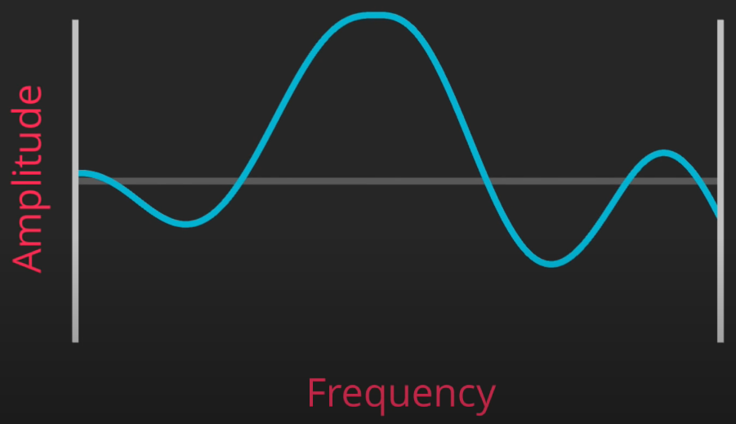

Figure : Visual axis representation of an octave

Amplitude represents values scaled along the Y-Axis.

Frequency represents values scaled along the X-Axis.

### 3.3.3 Octaves, Lacunarity and Persistence

To add detail to terrain, whilst maintaining its overall shape; multiple layers of noise (or noise maps) are levelled on top of each other.

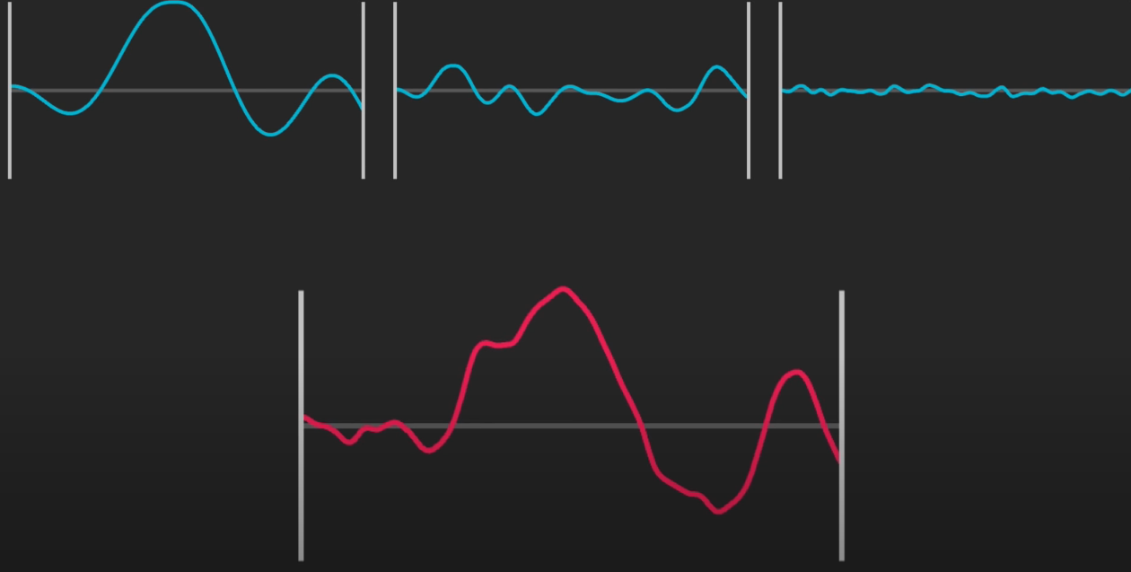

Figure : 3 octaves (blue) and their result when added (red)

To allow for each subsequent octave to increase in detail, a variable called ‘Lacunarity’ is used. Lacunarity is a variable that controls the increase in frequency of octaves, the lacunarity variable essentially controls how many Perlin noise maps are added together.

For example:

* *Octave 1*: Frequency = Lacunarity ^ 0
* *Octave 2:* Frequency = Lacunarity ^ 1
* *Octave 2:* Frequency = Lacunarity ^ 2
* Etc, etc, etc; increasing for how many octaves we want

So if Lacunarity was set to 2; we would get frequency values of:

* *Octave 1*: Frequency = Lacunarity ^ 0 = **1**
* *Octave 2:* Frequency = Lacunarity ^ 1 = **2**
* *Octave 2:* Frequency = Lacunarity ^ 2 = **4**

As each octave increases in detail, it’s influence should diminish; to allow for this we create a new variable called ‘Persistence’. Essentially, this variable controls the decrease in amplitude of octaves. With Persistence introduced to control the amplitude of octaves:

* *Octave 1*: Amplitude = Persistence ^ 0
* *Octave 2:* Amplitude = Persistence ^ 1
* *Octave 2:* Amplitude = Persistence ^ 2

Using a persistence value, in the range 0 – 1, enables us to affect how rapidly the amplitude decreases with each octave. If we set the value of our persistence variable to 0.5, we would get amplitude values of:

* *Octave 1*: Amplitude = Persistence ^ 0 = **1**
* *Octave 2:* Amplitude = Persistence ^ 1 = **0.5**
* *Octave 2:* Amplitude = Persistence ^ 2 = **0.25**

### 3.3.4 Generating and Rendering a 3D Mesh

To render a 3D mesh, the height coordinates of a flat plane are set at different appropriate points. 3D meshes in Unity are made up of triangles, so the project must supply an array of integers and use a height map to set the coordinates of each vertex.

### 3.3.5 Improving Performance: Levels of Detail (LOD)

A common solution to improve performance when rendering many meshes is to implement support for rendering different mesh resolutions, or Levels of Detail (LOD). This way meshes can be rendered with fewer vertices and triangles. In the project, meshes further from the viewer will be lower resolution, whilst meshes closer to the viewer will be of a higher resolution.

For example, if we take a map with a width of 9 points from 0 to 8 then when the mesh is generated from this map each point will be looped and incremented by one; each point will be visited and a vertex will be created for this point.

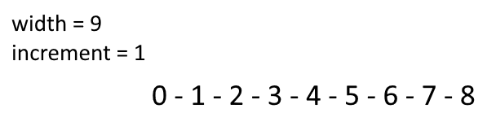

Figure : An array of points from 0 to 8

To simplify the mesh, when looping through the points instead of incrementing by one and making a vertex for each point; you could instead increment by 2, there by skipping every other point and reducing the number of vertices created.

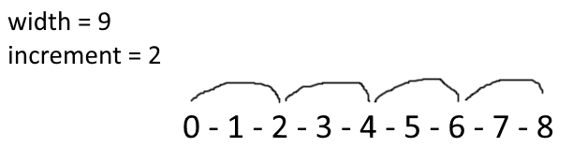

Figure : An array of points being incremented by 2

To simplify the mesh further, simply increase the increment value.

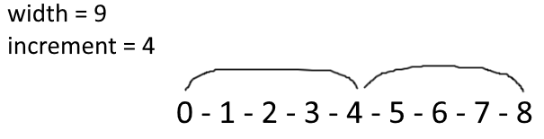

Figure : An array of points being incremented by 4

Not just any number can be used for the increment value however, if we take the same example with an increment of 3; we will encounter an error.

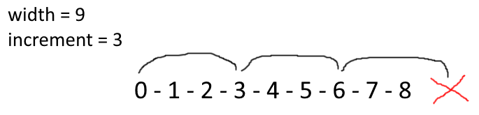

Figure : An error occurring from an array of 9 points being incremented by 3

This means that the increment value must be a factor of width minus 1. E.g. if width is 8, increment can be either; 1, 2, 4 or 8. The number of vertices per line = ((the width minus 1) divided by the increment) plus 1.

### 3.3.6 Improving Performance: Mesh Chunks

To render an infinite world, a chunks technique is used. The game world is divided into a grid of equally sized chunks and only terrain chunks that are visible to the viewer are rendered. As the viewer moves into visible range of a chunk, that chunk is then rendered and when a chunk leaves visible range of a viewer it is no longer rendered. This is how an infinitely large world is generated on a computer with limited memory capacity.

# Chapter 4: Design / Development / Solution

## 4.1 Project Setup

To setup the project, Unity and Visual Studio 2013 are installed and a new empty 3D Unity project called “Software Development Project” is created. Since I used an agile methodology to develop this project, this chapter describes my development journey as I was developing it. For example, when I completed an objective I would update this report with how it was done; then when I completed another objective I would update the report again, this was done until completion. This is why some of the code shown earlier in the chapter is revised later in the chapter.

## 4.2 Generating and Rendering a Perlin Noise Map

The first major step of the project is generating a Perlin noise map and having it rendered to the screen as texture.

### 4.2.1 Generating a noise map: Noise.cs

First, a C# script called “Noise.cs” is created; this script is programmed to generate noise maps. To generate the noise maps Perlin noise is used, this is because Unity provides an implementation of Perlin noise in its maths class “*(Mathf.PerlinNoise(float x, float y);*”.



Figure : Noise.cs script as seen from the Unity editor

Inside this script a method called “GenerateNoiseMap” is created, this method will generate the noise map; it will return a grid of values between 0 and 1. GenerateNoiseMap will return a 2D array of float values, eventually this method will accept a large number of arguments; including lacunarity and persistence values (as discussed in problem analysis). However, for now, it will accept 3 arguments that define the noise map dimensions; “int mapHeight”, “int mapWidth” and “float scale”.



Figure : GenerateNoiseMap method with 3 arguments

In the body of the method, a 2D float array called “noiseMap” is created, with size “mapWidth” and “mapHeight”.



Figure : Creation of a 2D array called "noiseMap"

In the method, we will loop through the x and y values of the noise map with a “for loop”. In this loop we deduce at which points the height values will be sampled from (“float sampleX, “float sampleY”) and divide these values by the scale to create non-integer values.

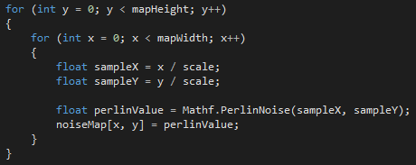

Figure : A for loop to find x and y sample coordinates and the Perlin Value

We could encounter a division error here however, as if “scale” is set to zero we will get a division by zero error. To prevent this from happening we use an “if statement” before this point to clamp the scale value.

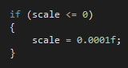

Figure : If statement to clamp the scale value

Using the sample coordinates, we can create a “float perlinValue” using these values and apply it to the noiseMap. Finally, returning the noiseMap that has been created.

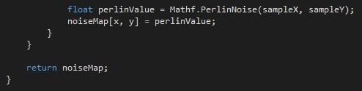

Figure : Perlin value calculated and noise map returned

There is still a lot more work to be done on the GenerateNoiseMap method, but for now it is programmed sufficiently to be drawn onto the screen so we can visualise what we are working with. At this point, this is how the Noise.cs script looks:

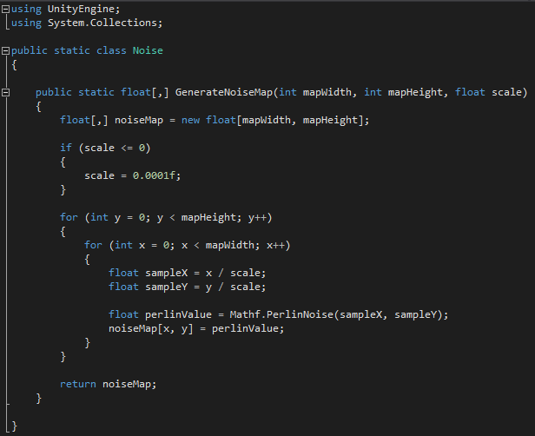

Figure : Initial code for the Noise class

### 4.2.2 Rendering the noise map: MapGenerator.cs and MapDisplay.cs

To draw our noise map to the screen, a new C# script called “MapGenerator.cs” is created; this script will be programmed to allow for the noise map created inside the “Noise.cs” script to be rendered to the screen when applied to an object in our Unity scene. Another script called “MapDisplay.cs” is also created, this will be used later.



Figure : MapGenerator.cs and MapDisplay.cs as seen from the Unity editor

Before programming this new “MapGenerator.cs” script, an empty object called “Map Generator” is added to our Unity scene and the “MapGenerator.cs” and “MapDisplay” scripts are applied to the object. A plane object is also added to the Unity scene.

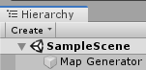

Figure : Map Generator object in the Unity scene hierarchy

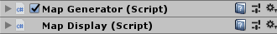

Figure : MapGenerator.cs applied to Map Generator object

In the “MapGenerator.cs” script a number of values for the noise map are defined, these values are “int mapWidth”, “int mapHeight” and “float noiseScale”.

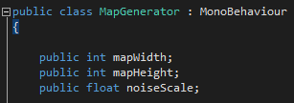

Figure : Declaration of mapWidth, mapHeight and noiseScale variables

Here, the 2D noise map is fetched from the noise class. For now, the noise map is passed along to the map display class (created earlier) so that it can draw the noise map to the screen.

Before continuing to develop “MapGenerator.cs”, we must first programme “MapDisplay.cs”. Inside “MapDisplay.cs” a reference to the renderer of the plane object called “textureRenderer” is created, also, a public method called “DrawNoiseMap” is created; this method takes in the 2D float array of the noise map. “DrawNoiseMap” will calculate the width and height of the given noise map:

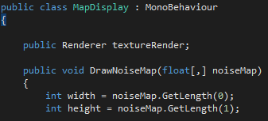

Figure : DrawNoiseMap method to calculate width and height of noise map

Now, a 2D texture (simply called “texture”) is created with the width and height of the noise map assigned to it.



Figure : Texture created with width and height of noise map

Now, the colour of each of the pixels in the texture is set; this is done by generating an array (with a size of width*height) of all of the colours for all of the pixels and then setting/applying them all at once. The colour array used is called “colourMap”.

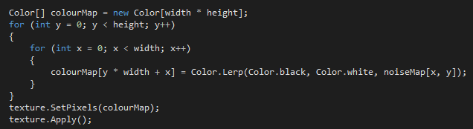

Figure : For loop to assign pixel colours

To allow the developer to preview the noise map without entering game mode, the shared material’s texture is set to the texture we have just generated. Also the size of the plane object is set to the same size as the noise map.



Figure : Shared material texture set

This finishes the programming of “MapDisplay.cs” for now.

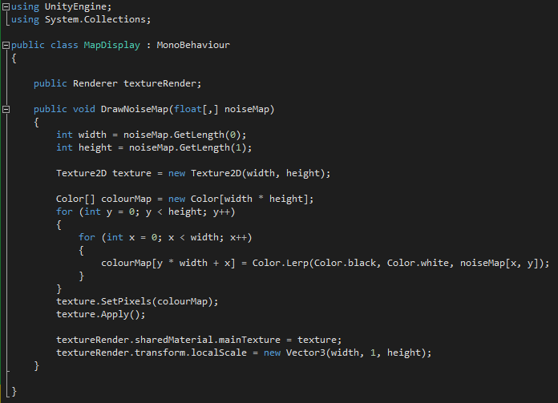

Figure : Initial draft of MapDisplay.cs

Now, back inside “MapGenerator.cs”, we get a reference to the MapDisplay; then the noise map is passed in and drawn.

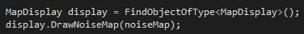

Figure : Reference to map display inside MapGenerator.cs

### 4.2.3 Rendering the noise map: Map Material and Editor Script

The final step towards rendering the noise map is creating a material for the noise map to be displayed upon. This material is called “Map Mat”. This material is created and set and an unlit texture shader, this is because there is no light in the scene. This material is applied to the plane in the scene.

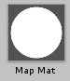

Figure : Map material as seen in the Unity editor

Currently, there is no way for the “MapGenerator.cs” generate noise map method to be called; to fix this an editor script is created to allow the method to be called from inside the Unity editor. This editor script is called “MapGeneratorEditor”. In this script, the “OnInspectorGUI()” method is overridden and the script is programmed to allow the developer to press a button in the Unity editor to generate the noise map.

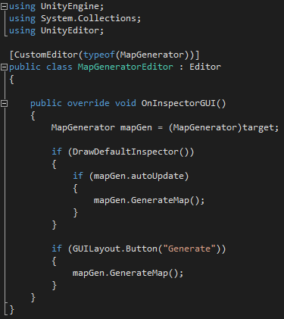

Figure : Editor script and GUI override

Now, with all of the scripts, object and materials programmed and placed; a Perlin noise map can be generated and rendered to the screen.

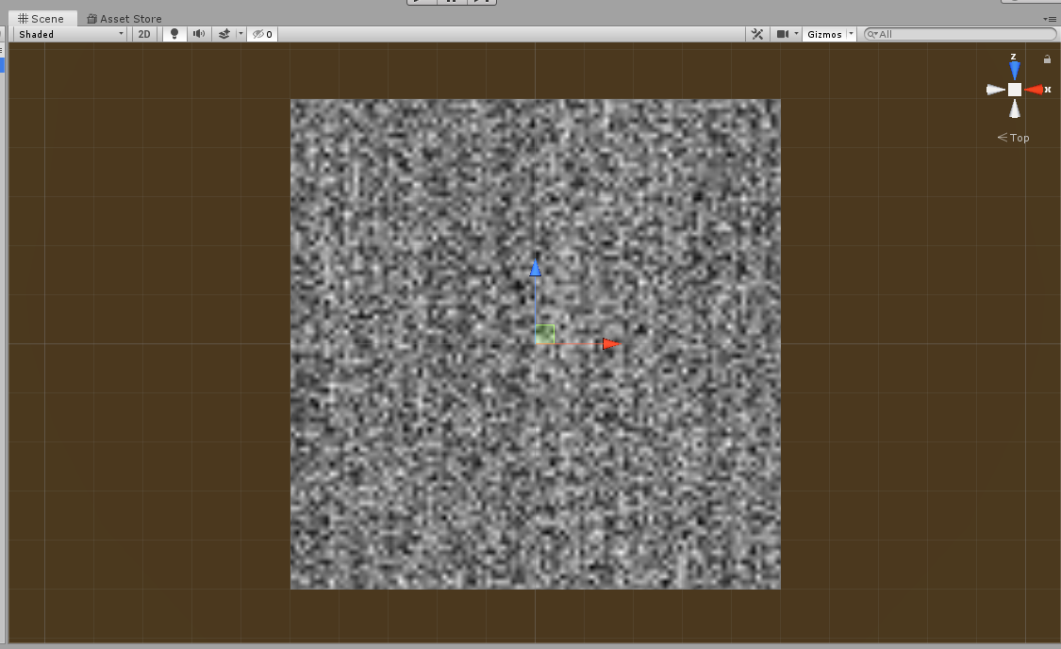

Figure : Initial Perlin noise map being rendered to screen

In its current state, the size and scale of the map can be changed in the editor.

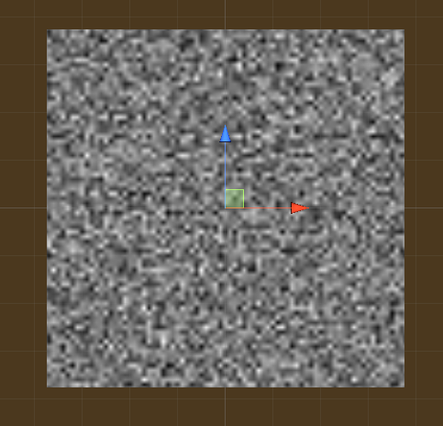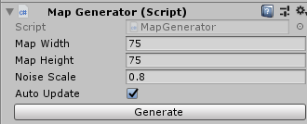

Figure : Map Width, Map Height, Noise Scale and Auto Update options in Unity editor

## 4.3 Greater Perlin noise map control

Currently, the Unity project will generate a Perlin noise map and render it to the screen as a texture. The user can control the height and width of the noise map, as well as the scale. Now, the project will be developed further to allow for the user to control the Octaves, Persistence, Lacunarity, Seed and Offset parameters of the noise map.

### 4.3.1 Octaves, Persistence and Lacunarity

Inside the “Noise.cs” script, three new arguments are added to the “GenerateNoiseMap” method, these arguments will allow the user to control the number of octaves, another to control the persistence value and another argument to control the lacunarity value; these are called “int octaves”, “float persistence” and “float lacunarity” respectively.



Figure : GenerateNoiseMap method with seed, scale, octaves, persistance and lacunarity arguments added

A for loop is added to the method to loop through the octaves (with previous code placed inside the loop), and outside the loop the amplitude and frequency variables are declared; named “float amplitude” and “float frequency” respectively. A new variable, “float noiseHeight” is also declared to track the current height value.

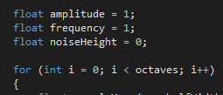

Figure : Declaration of amplitude, frequency and noiseHeight variables

Now, instead of setting the noise map directly equal to the perlinValue, the noise height is increased by the Perlin value of each octave. Also, for the frequency value to take effect, the sample coordinates are multiplied by the frequency value. This means that; the higher the frequency, the further apart the sample points will be which will mean that the height values will change more rapidly. Furthermore, by default the value that is generated from “Mathf.PerlinNoise” is in the range 0 to 1; but to get more interesting noise it would be ideal if the Perlin value could sometimes be negative so that the noise height would decrease; to change the range to be -1 to 1 instead of 0 to 1 the Perlin value is multiplied by 2 and subtracted by 1.

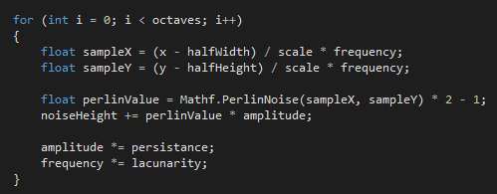

Figure : Octaves loop with scale and frequency applied; variable values calculated

Next, “float noiseHeight” is applied to the noise map outside of the octaves loop.



Figure : noiseHeight applied to noiseMap

Before “return noiseMap;”, it must be normalised so that all of the values are back in the range of 0 to 1. To do this, the lowest and highest values of “noiseMap” are tracked. Outside of the for loops, “float maxNoiseHeight = float.MinValue;” and “float minNoiseHeight = float.MaxValue;” are declared.

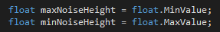

Figure : maxNoiseHeight and minNoiseHeight variables declared

An if and else statement are used to track the minimum and maximum noise height values (the range of the noise map height values).

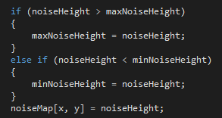

Figure : If and else statement to track min and max noise height

Now that the range of the noise map values can be tracked, all of the noise map values are looped through again and for each value in the noise map; they are set to “Mathf.InverseLerp(minNoiseHeight, maxNoiseHeight, noiseMap[x,y]”. This inverse lerp method returns a value between 0 and 1, for example; if the noiseMap value is equal to the minNoiseHeight then it will return 0, if its equal to the maxNoiseHeight then it will return 1, if it was halfway between them it will return 0.5, etc. This means the noise map has been effectively normalised and we can happily “return noiseMap”.

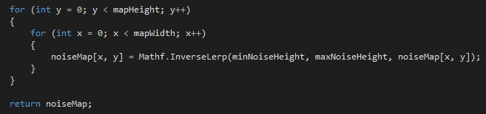

Figure : noiseMap being normalised

Inside “MapGenerator.cs”, the three parameters are added; and this will allow the user to now control the octaves, persistence and lacunarity of the noise map from the editor.

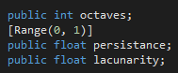

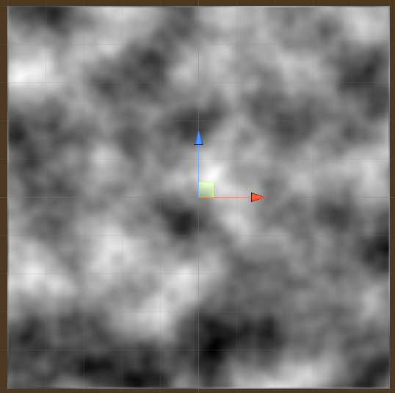 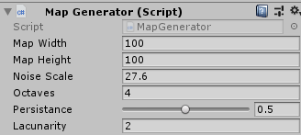

Figure : New Perlin noise map rendered with additional variables/parameters

With the octaves, persistence and lacunarity values added to the noise map generation process; the result is much more ideal.

### 4.3.2 Seed

It would be ideal though if the project could generate a number of unique noise maps, this is done by sampling the points from radically different locations. This ability will be controlled by the “Seed” value.

In “Noise.cs”, the “int seed” argument is added to the GenerateNoiseMap method and a Pseudo Random Number Generator (prng) is used to select a random number and have the “Seed” value set to this number.



Figure : Pseudo Random Number Generator

To have each octave sampled from a different location, a Vector2 array is created called “octaveOffsets” with a length of “octaves”. Then a for loop is used to set “float offsetX” and “float offsetY” to a value in the range of negative 100000 to positive 10000. This range is set as there is an error where if the range is too large then the same number will be returned by the number generator every time. Also, to allow the user to scroll through the noise by inputting their own offset values, the “Vector2 offset” value is added to the GenerateNoiseMap method and when the offset is calculated this value is added. (The seed and offset parameters are added to MapGenerator.cs at the end).

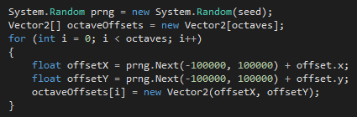

Figure : prng and offsets added to octaves loop

So, when the sample points are being chosen the octaveOffsets value is added to each sample.



Figure : offsets added to sample coordinated

Now from the editor, the user can input a seed value to sample octaves from radically different positions; as well as scroll through the noise using the offset values.



Figure : Seed and Offset variables as seen in the Unity editor

### 4.3.3 Noise Scale and OnValidate

Currently, as the noise scale is changed the noise map is scaled from the top right of the texture. It would be more appropriate to have the noise map scale from the centre. This feature is simply implemented; in “Noise.cs” “float halfWidth” and “float halfHeight” are declared and subtracted from the sample values.

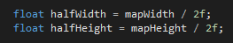



Figure : halfWidth and halfHeight declared and subtracted from the sample coordinates

Finally, the mapWidth, mapHeight and lacunarity need to be clamped to prevent their values from being below 1, also the octaves value should never fall below 0. These values are clamped by using the OnValidate method inside “MapGenerator.cs”.

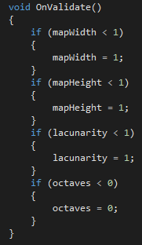

Figure : mapWidth, mapHeight, lacunarity and octaves variables clamped by OnValidate method

## 4.4 Colour Maps

The next aim of the project is to generate a colour map by using the noise map that has been programmed. The user will be able to define different terrain types (grasslands, water, mountain, etc) by assigning a colour to different height ranges.

### 4.4.1 Creating Regions and assigning Colours to Height Values

To begin, inside “MapGenerator.cs”, a structure called “TerrainType” is created; in this struct a number of parameters for the terrain are defined. Including; “float height”, “Color colour” and “string name”. An array of TerrainTypes called “regions” is also created.



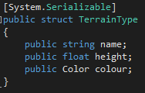

Figure : TerrainType struct with name, height and colour variables

From the editor, the user can now define how many terrain regions they want; as well as assign a name, height, and colour to the region (showcased later). Next, a for loop is used to loop through the x and y values of the noise map to find out which region they fall within; to be clear, this is decided by the value the user assigns to the height variable in the TerrainType struct that has just been created. Also, just how in the “MapDisplay.cs” class, a one dimensional colour map (albeit, a black and white one) is being created to render the noise map texture; the same technique will be used here.

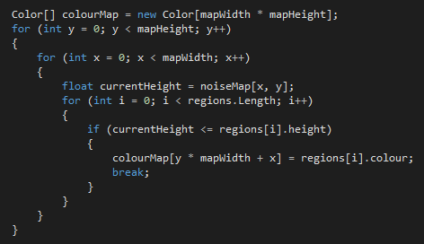

Figure : Colour map generated

### 4.4.2 Draw Mode: Nosie Map and Colour Map

Although a colour map is being created, it would be preferable if the user could choose whether the noise map or the new colour map is displayed. To do this, an enum called “enum DrawMode” is created. So, using this enum; the user can decide whether the black & white noise map is drawn or the new colour map is drawn to the screen.

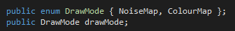

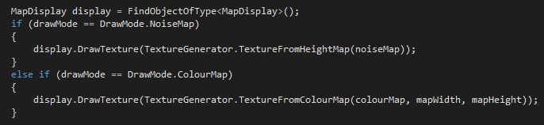

Figure : DrawMode enum declared and added to map display

### 4.4.3 TextureGenerator.cs

Currently, the texture creation code is situated within the “MapDisplay.cs” class. This code will be separated from that script and placed in a newly created script called “TextureGenerator.cs”.



Figure : TextureGenerator.cs script as seen in the Unity editor

This script will have a method to create a texture from a one dimensional colour map, this method is called “TextureFromColourMap”. There will also be another method for getting a texture based on a 2D height map, this method is called “TextureFromHeightMap”.

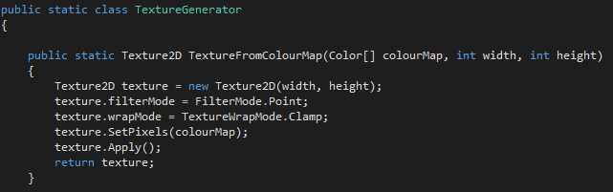

Figure : TextureFromColourMap method

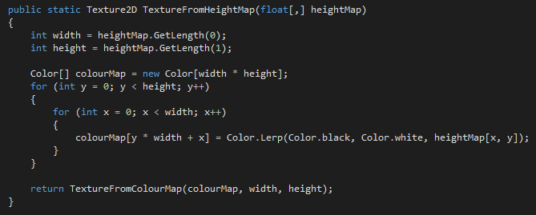

Figure : TextureFromHeightMap method

Since the Unity project no longer just draws a noise map texture, it can also draw a colour map texture; the code inside “MapDisplay.cs” is changed to reflect this.

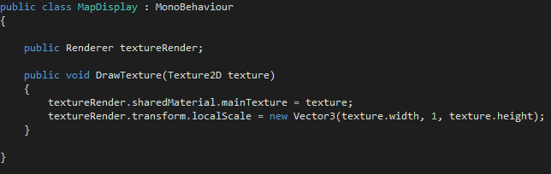

Figure : DrawTexture method with colour map changes

### 4.4.4 Colour Map Final Result

In the editor, the user can now set the draw mode of the map generator.

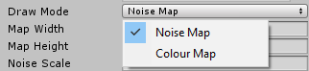

Figure : The Draw Mode option as seen in the Unity editor

The user can also define the regions of the colour map, and generate the colour map to showcase those regions.

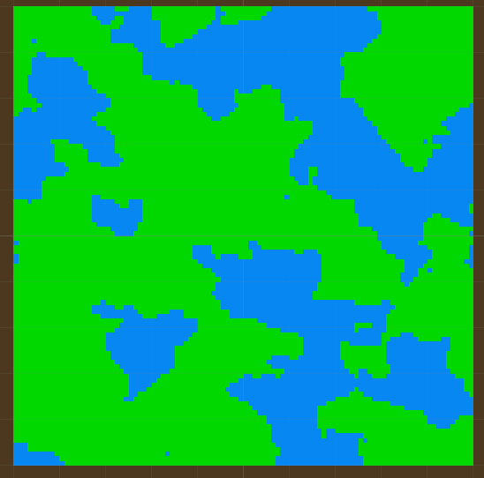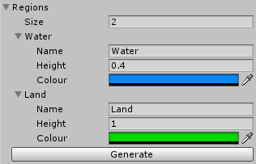

Figure : Colour map rendered with 2 regions defined by the user

By defining more regions, the user can make the colour map look a lot more advanced; this way the colour map will resemble a terrain map. Also, changing the seed, persistence, lacunarity, offset, etc, will change the shape of the landscape.

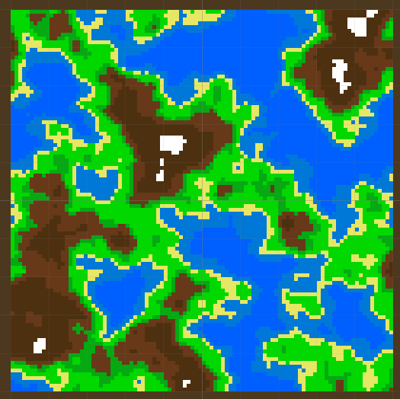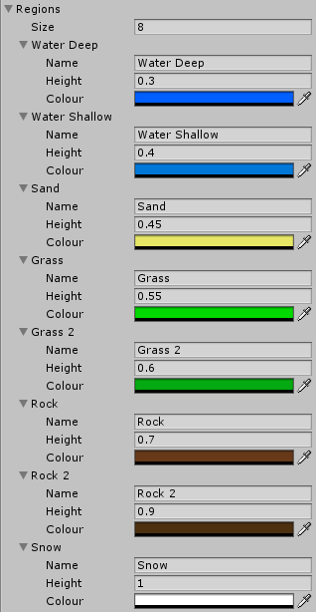

Figure : Colour map rendered with 8 regions defined by the user

## 4.5 3D Mesh

Now that the project can generate noise maps and colour maps, with a large amount of user control; then next step is to generate a 3D terrain mesh. This is done by using a flat plane and setting the heights of the individual vertices.

### 4.5.1 MeshGenerator.cs: Vertices, Triangles

A new script called “MeshGenerator.cs” is created.



Figure : MeshGenerator.cs script as seen in the Unity editor

Inside this script a method called “GenerateTerrainMesh” is created with the 2D float array of the heightMap accepted as an argument. A for loop is added to the method, it loops through the height map and creates vertices.

To create these vertices another class needs to be created, called “MeshData”. This contains a Vector3 array called “vertices”, an int array called “triangles” and a constructor called “MeshData” which will take in the meshWidth and meshHeight, the variables are initialised inside the constructor.

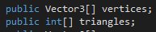

Figure : Vector3 vertices and int triangles

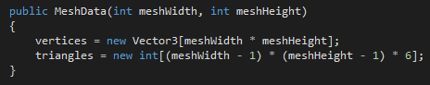

Figure : MeshData method with meshWidth and meshHeight arguments

Another method for adding triangles is also created called “AddTriangle”, it will take in three integers for the three vertices of each triangle.

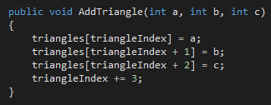

Figure : AddTriangle method to add triangles

Back in the GenerateTerrainMesh method, a new variable “MeshData meshData” is declared and width and height are passed in. “int vertexIndex = 0” is also declared and at the end of each loop this variable is incremented so that the position in the array is tracked.

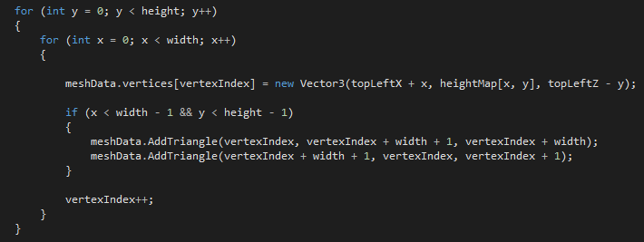

Figure : For loop to increment vertices

### 4.5.2 UV Maps

With the fundamentals of mesh generation now programmed, the next step is creating a UV map so that textures can be added to the mesh.

Staying in “MeshGenerator.cs”, in the MeshData method; a Vector2 array called “uvs” is created. One of these is needed for each vertex; so this is implemented into the MeshData constructor.

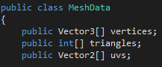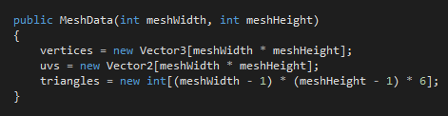

Figure : UV array implemented into MeshData

In the GenerateTerrainMesh method, each vertex needs to be told where it is in relation to the rest of the map as a percentage for both the x and y axis; this is a percentage between 0 and 1.

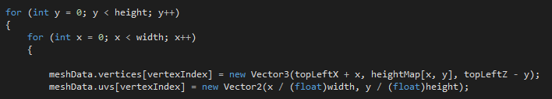

Figure : For loop to tell each vertex position as percentage

In the MeshData class, a method called “CreateMesh” is created; this method will get the mesh from the mesh data. In this method the normals will be recalculated so that lighting works appropriately.

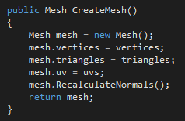

### 4.5.3 Rendering the Mesh

We now need to render/draw the mesh to the screen. To facilitate this, a new draw mode called “Mesh” is added to the draw mode enum inside “MapGenerator.cs”.





Figure : Mesh DrawMode

References to a meshFilter and meshRenderer are declared and the DrawMesh method is added to “MapDisplay.cs”.

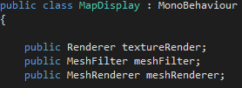

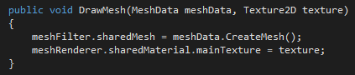

Figure : meshRenderer and meshFilter references

A new empty object called “Mesh” is added to the scene, with a mesh filter and mesh renderer component added.

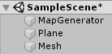

Figure : Empty Mesh object in Unity editor

A new mesh material called “Mesh Mat” is added, with smoothness set to 0. This material is added to the Mesh object.

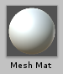

Figure : Mesh Material as seen in the Unity editor

The new mesh object is assigned to the Mesh Filter and Mesh Renderer of the MapGenerator object, inside the map display class.

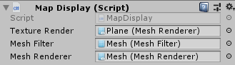

Figure : Map Display script in the Unity editor with the Mesh Filter and Mesh Renderer assigned

Now, if the draw mode is set to mesh; the mesh will generate (at this point the mesh is flat).

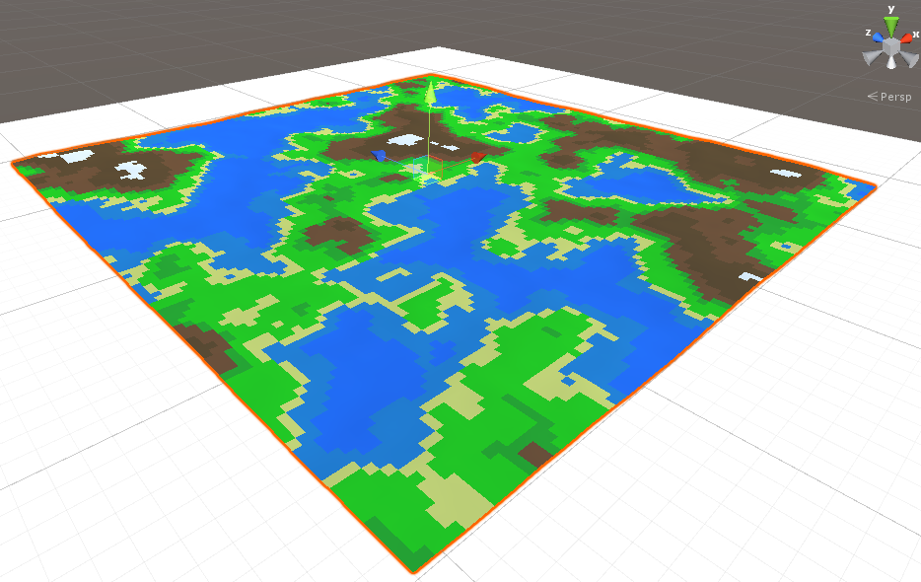

Figure : Flat 3D mesh generated and rendered

## 4.6 Height Multiplier and Height Curve

The project can now render a 3D terrain mesh, the next aim is to add some variable to act as a multiplier for the height values so that it is no longer flat.

### 4.6.1 Height Multiplier

Inside “MeshGenerator.cs”; “float heightMultiplier” is added as an argument to the GenerateTerrainMesh method and when the script creates the vertices the y values will be multiplied by the heightMultiplier.

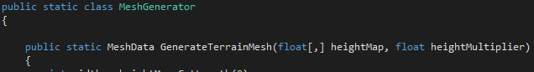



Figure : heightMultiplier implemented into MeshGenerator

In “MapGenerator.cs”, a variable called “float meshHeightMultiplier” is declared and passed in as a parameter to the terrain mesh call.





Figure : meshHeightMultiplier passed as parameter to the terrain mesh call

Now, if this meshHeightMultiplier is changed in the editor; the vertex heights will increase.

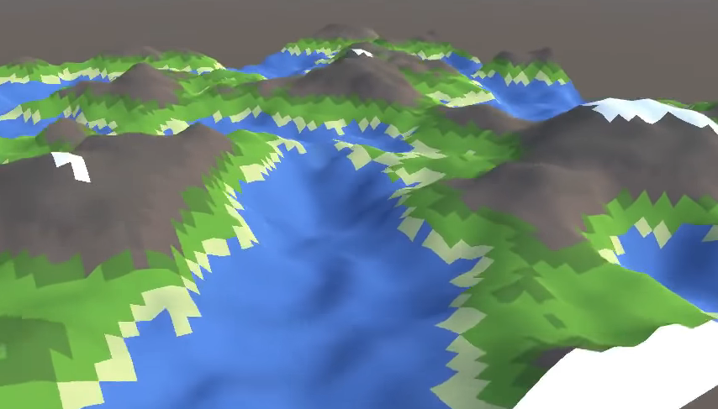

Figure : 3D Terrain Mesh with heightMultiplier implemented

There is an issue however, the water region is also being affected; creating hilly looking water. To correct this a curve that allows the user to specify how much different height values should be affected by the multiplier needs to be created.

### 4.6.2 Height Curve

Inside “MapGenerator.cs”, a variable of type AnimationCurve called “meshHeightCurve” is created. This adds a curve to the editor.





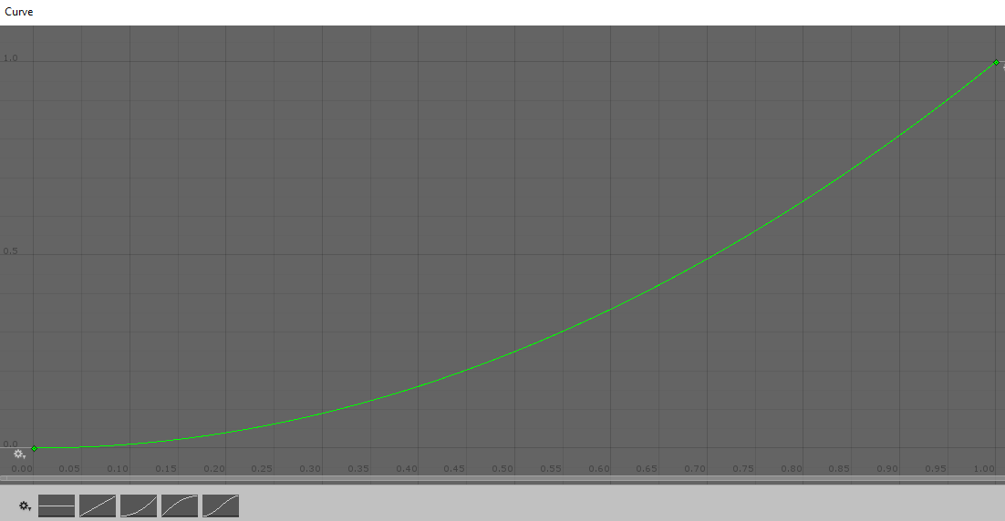

Figure : Mesh Height Curve

The values on the x axis, from 0 to 1, represent the actual height values that are stored in the map. With the y value the user can define what those values become in the mesh. For example, if the user wanted all the values from 0 to 0.4 to be flat (such as in this case with the water region), a key can be added to the curve to flatten it.

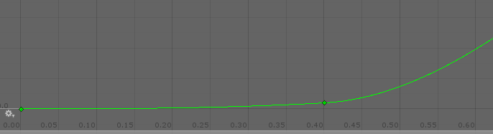

Figure : Mesh Height Curve with key added

To implement this, the meshHeightCurve needs to be added to DrawMesh in MapGenerator.cs. It also needs to be added as an argument to the GenerateTerrainMesh method in MeshGenerator.cs.





Figure : meshHeightCurve added to DrawMesh and GenerateTerrainMesh

The value from the height map will be used to get the corresponding value from the height curve.



Figure : Corresponding height map values from height curve

With this height curve implemented, the results are evident; the water region is affected much less by the height multiplier.

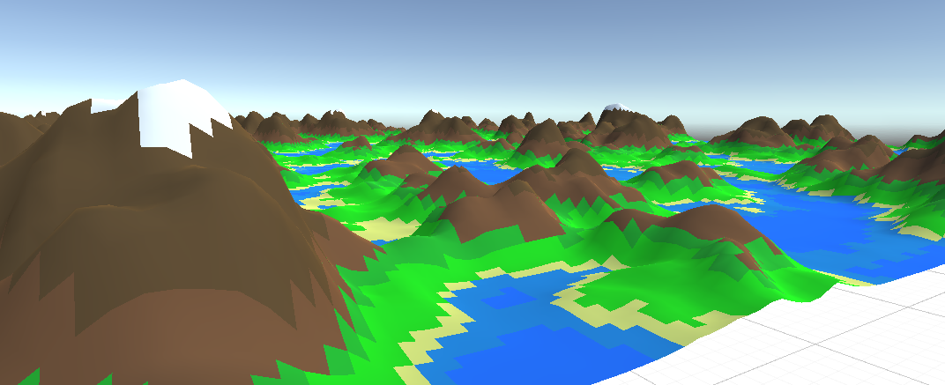

Figure : 3D Terrain Rendered with height curve implemented

## 4.7 Level of Detail (LOD)

The next aim is to implement support for multiple mesh resolutions, this is a pre-emptive step so that when the project can generate larger terrains made from multiple meshes (endless terrain system); the mesh chunks in the distance can be rendered with fewer vertices and triangles to keep the Unity project running smoothly.

In MapGenerator.cs, a constant integer called “mapChunkSize” will be created; this will replace the previous “mapWidth” and “mapHeight” variables. An integer called “levelOfDetail” is also added, it will be clamped in the range 0 to 6.

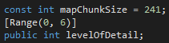

Figure : mapChunkSize and levelOfDetail variables declared

The levelOfDetail is passed into the GenerateTerrainMesh method, an in the OnValidate method the code for mapChunkSize can be removed.



Figure : levelOfDetail variable passed into GenerateTerrainMesh method

In MeshGenerator.cs, the levelOfDetail variable is added as an argument to the GenerateTerrainMesh method.



Figure : levelOfDetail variable added as argument to GenerateTerrainMesh method

Within the method, the “meshSimplificationIncrement” integer is declared as being equal to levelOfDetail*2, with an if statement declaring that the variable will be 1 if levelOfDetail is equal to 0.



Figure : meshSimplificationIncrement declared

Next is to figure out how many vertices there are per line.

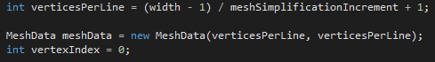

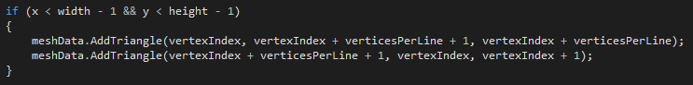

Figure : Number of vertices per line calculated

That’s it, now if we change the scene to shaded wireframe mode so that we can see the triangles that make up the mesh and change the Level of Detail; we can see it’s effect on the detail of the mesh and its number of triangles (Higher LOD = Less Triangles).



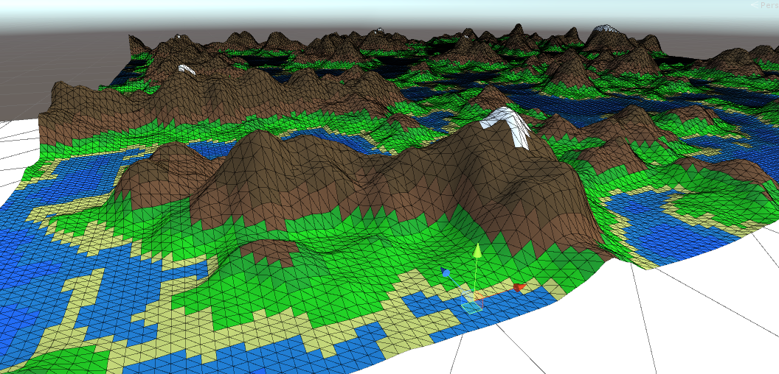

Figure : 3D Terrain rendered at highest LOD



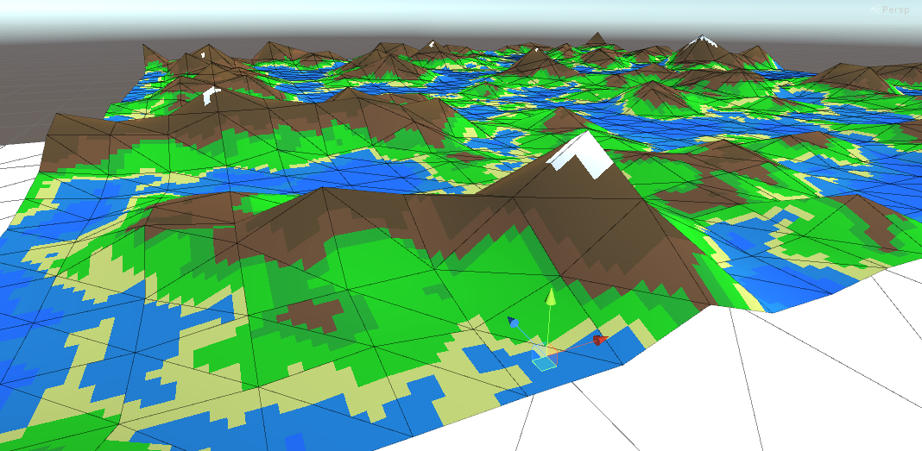

Figure : Same mesh as Figure 82 with a simpler LOD

## 4.8 Endless Terrain System: Viewer and Terrain Chunks

The next big step of the project is to implement an endless terrain system; this will be done by only rendering chunks of terrain that are visible to the player/viewer and reducing the level of detail of terrain chunks that are further away from the player. To start, a new script called “EndlessTerrain.cs” is created.



Figure : EndlessTerrain.cs script as seen in the Unity editor

In this script some variables are declared, such as; “const float maxViewDst” (this stores how far the viewer can see), a reference to the viewers transform called “Transform viewer”, a Vector2 to store the viewer position called “Vector2 viewerPosition”, an integer to store the size of the terrain chunks called “int chunkSize” and an integer to store which chunks are visible to the player called “int chunksVisibleInViewDst”.

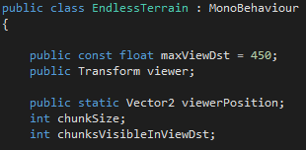

Figure : maxViewDst, Transform viewer, Vector2 viewerPosition, chunkSize and chunksVisibleInViewDst variables declared

Next, a Start method is created; this method will fetch the chunk size which is stored in MapGenerator.cs and then declare that the number of chunks visible is equal to the max view distance divided by the chunk size.

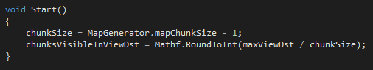

Figure : Start method to fetch the chunk size from MapGenerator.cs

A method to update the visible chunks called “UpdateVisibleChunks” is created; this method will get the x and y coordinate of the chunk that the viewer is placed within and then for loop through all of the surrounding chunks and store their x and y coordinates in a Vector2 called “viewedChunkCoord”.

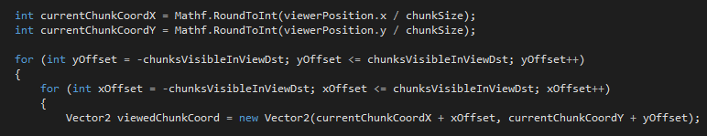

Figure : for loop to store x and y coordinates of chunks surrounding the viewer

A dictionary that stores all of the coordinates and terrain chunks is created; this prevents chunks from being duplicated when the viewer moves.



Figure : Dictionary to store coordinates and terrain chunks

In the UpdateVisibleChunks method, an if and else statement are used to handle cases for when the dictionary contains the key for a viewed chunk coordinated and for when it doesn’t contain the new viewed coordinate.

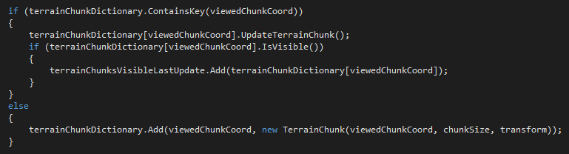

Figure : if and else statement to handle cases for when the dictionary contains the key for a viewed chunk

Within the script a “TerrainChunk” class is created.

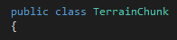

Figure : TerrainChunk class created

For the moment, this class will substantiate a plane object as a visual placeholder. This class will later be implemented with the MapGenerator so that the planes will be actual terrain. A constructor is created that takes in “Vector2 coord” and “int size” as arguments.

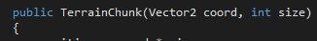

Figure : TerrainChunk constructor

Outside the constructor, “Vector2 position” is created and used within the constructor to store the value of the coordinate multiplied by the size.



Figure : Vector 2 position declared

Since the chunk will be placed in 3D space; “Vector3 positionV3” will be used to initialise the x, y and z position.



Figure : Vector3 position

Outside the constructor, “GameObject meshObject” is created and used inside the constructor to substantiate the placeholder plane object as well as setting its transform (position and scale). The object is not visible by default.



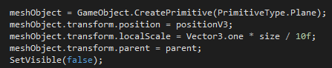

Figure : 2D Plane game object substantiated

Another method called “UpdateTerrainChunk” is created, this method will tell the terrain chunk to update itself; meaning the chunk will find the point on its perimeter that is closest to the viewers position and find the distance between that point and the viewer, if that distance is less than the maximum view distance then the mesh object will be enabled. If that distance exceeds the maximum view distance then the mesh object will be disabled. To find the point on the perimeter that is closest to another point; a “Bounds” struct is used.



Figure : bounds struct declared

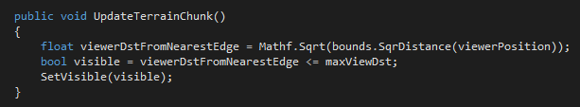

Figure : UpdateTerrainChunk method

To set a mesh object as visible, a method called “SetVisible” is created and used inside the UpdateTerrainChunk method.

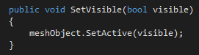

Figure : SetVisible method

Each frame the viewer position variable will need to be updated, so a new “Update” method is used. This method will also update the visible chunks.

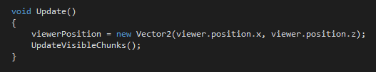

Figure : Update method

In the Unity editor, the EndlessTerrain.cs script is added to the MapGenerator object. A 3D cube object is also added to the scene, this will be the viewer; it is assigned to the viewer transform.

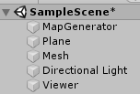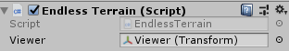

Figure : EndlessTerrain.cs script added to MapGenerator object; viewer object added to scene

Now, when the project is running; the terrain chunks (plane objects for now as a visual placeholder) within visible distance of the viewer will render. If the viewer moves, the rendered chunks will update; becoming visible or invisible depending on whether they are in visible range of the viewer.

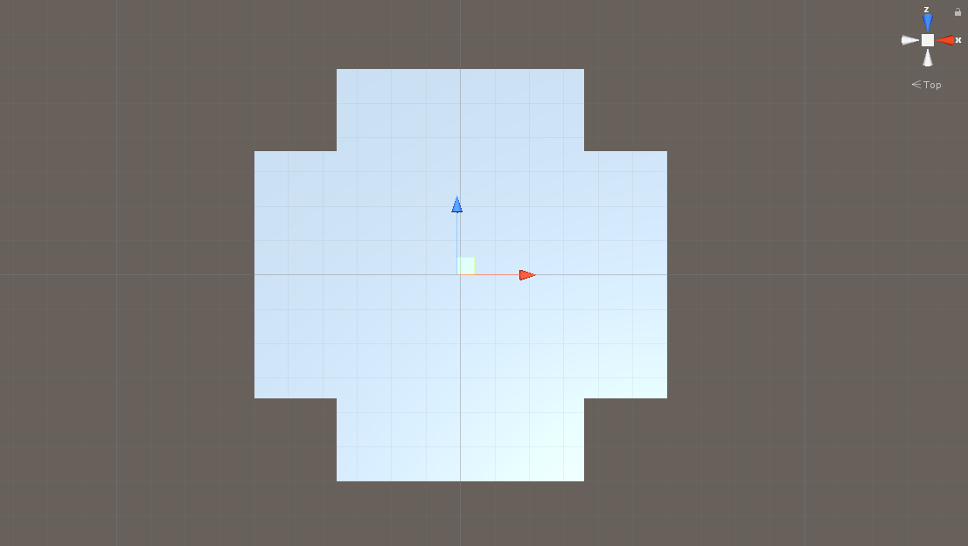

Figure : Chunks being generated around viewer

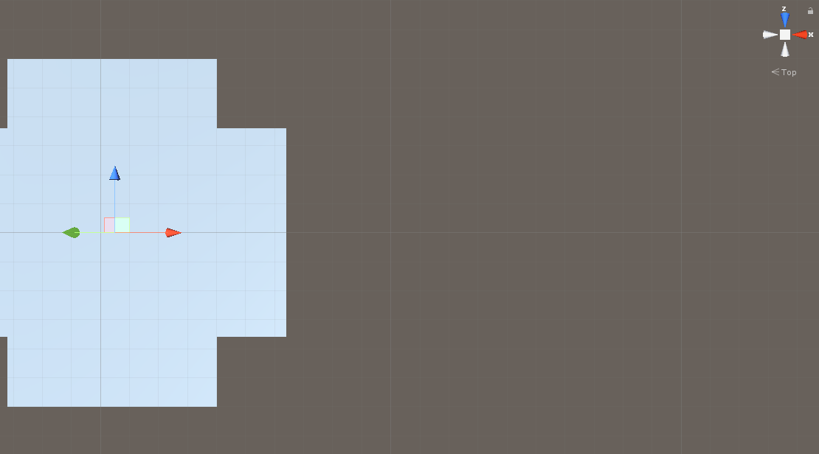

Figure : Rendered chunks dynamically updating as the viewer moves along the x axis

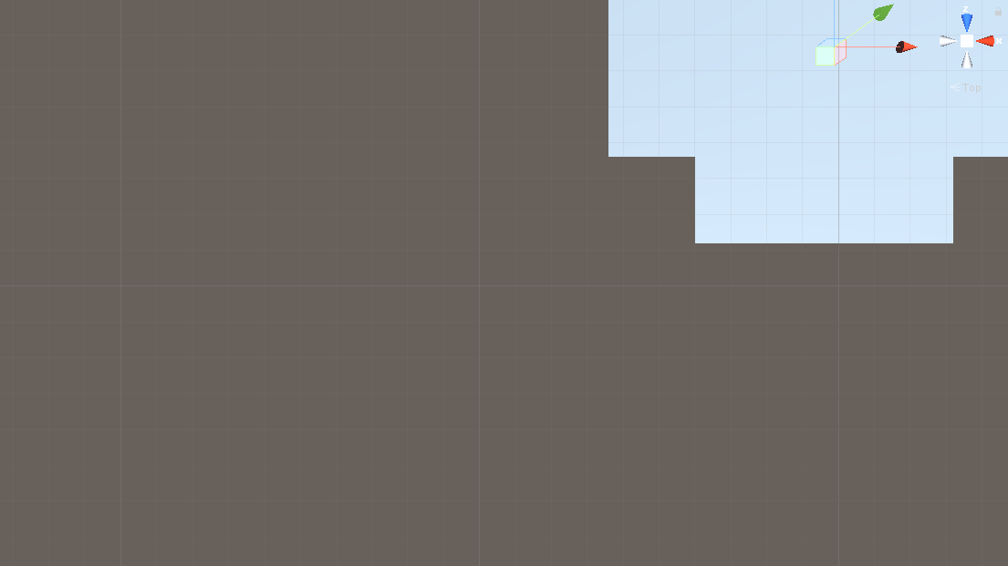

Figure : Rendered chunks dynamically updating as the viewer moves along the z axis

## 4.9 Endless Terrain System: Map & Mesh Integration and Threading

Now that the project can dynamically render and update chunks within visible range of the viewer; the next step is to integrate this system with the MapGenerator (so that the terrain mesh is rendered for the chunks, not just the plane object placeholder) and to add threading to reduce the impact on computer performance.

To begin, inside MapGenerator.cs, the code for drawing the map in the editor will be moved from the GenerateNoiseMap method to its own new method called “DrawMapInEditor”.

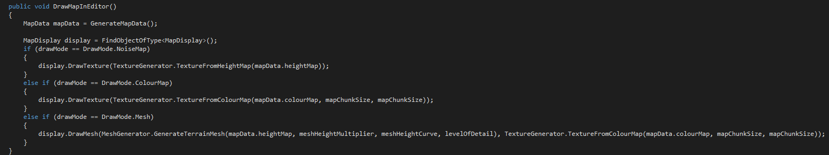

Figure : DrawMap code moved to new method called DrawMapInEditor

The purpose of implementing threading is to spread the calculations of the map data and the mesh data over multiple frames so that it doesn’t freeze the game project whilst processing. If the EndlessTerrain.cs class wants to get the map data from the MapGenerator.cs class; it can’t receive the map data back immediately because it is being calculated over multiple frames. So in MapGenerator.cs, a void method called “RequestMapData” will take in an Action parameter called “callback” so that in EndlessTerrain.cs when the map data is requested a method will be passed in as a variable, this method will be called “OnMapDataReceived”. The callback variable in the RequestMapData method refers to the OnMapDataReceived method and once the map data is finished calculating the OnMapDataReceived method is called and the calculated map data is passed in.

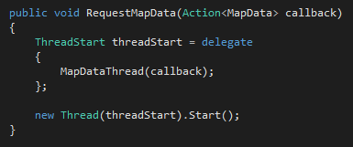

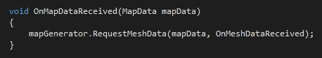

Figure : RequestMapData and OnMapDataReceived methods for threading

Essentially, the RequestMapData method is responsible for starting the map data thread (initiated in another method). Once the MapDataThread has got the map data it cant call the OnMapDataReceived thread directly because if you call a method from inside of a thread then it is processed on that thread also, the reason the project shouldn’t do this is because the OnMapDataReceived method will be responsible for tasks that are only allowed to be done inside Unity’s main thread (e.g. working with meshes and textures). To solve this, the map data and the callback are added to a queue and outside the thread (in the Update method) the queue is looped and when there is an item in the queue the callback is called and the map data is passed in.

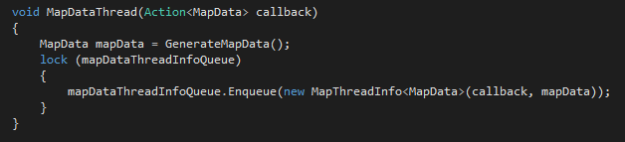

Figure : MapDataThread method to set up queue

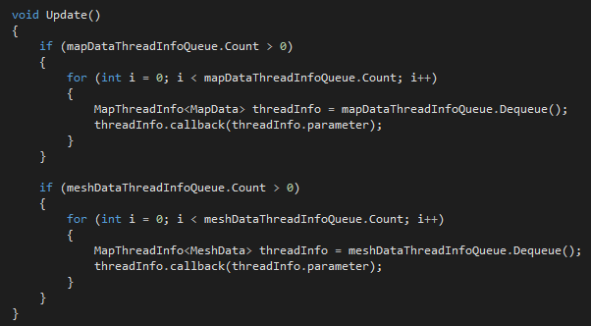

Figure : Update method to handle thread queue

The same technique will be used to thread the mesh data also, with similarly named methods.

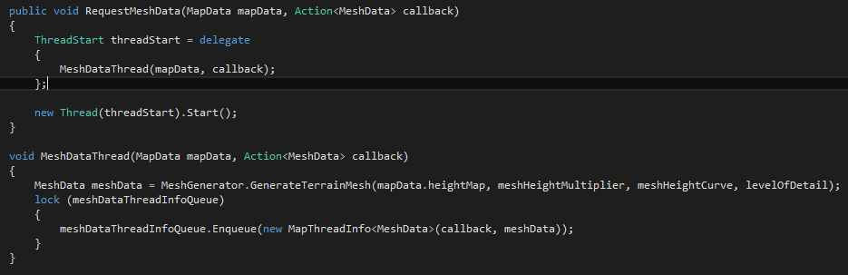

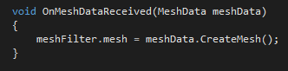

Figure : Threading technique being used for mesh data

Now, if the mesh material is applied to the EndlessTerrain.cs component on the MapGenerator object and the project is run; the map and mesh data is successfully threaded and the chunks will dynamically render the terrain meshes around the viewer as it moves. At the moment, the terrain chunks are not textured and the same mesh is being rendered for each chunk; the next steps are to implement the LOD system appropriately as well as add textures and render different meshes so that they chunks connect seamlessly.

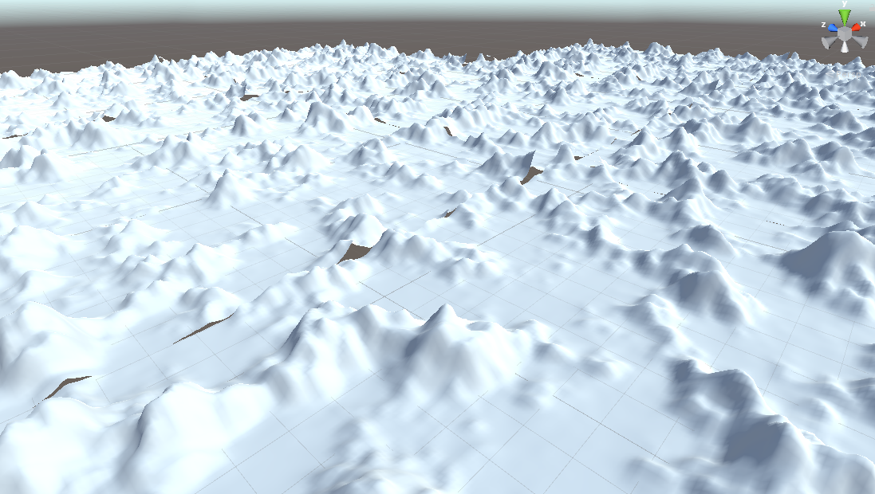

Figure : Chunks being rendered as terrain meshes

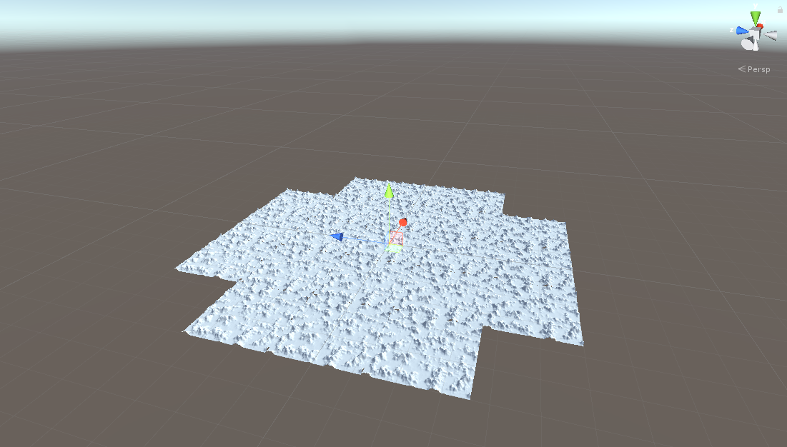

Figure : Terrain mesh chunks dynamically rendering around viewer

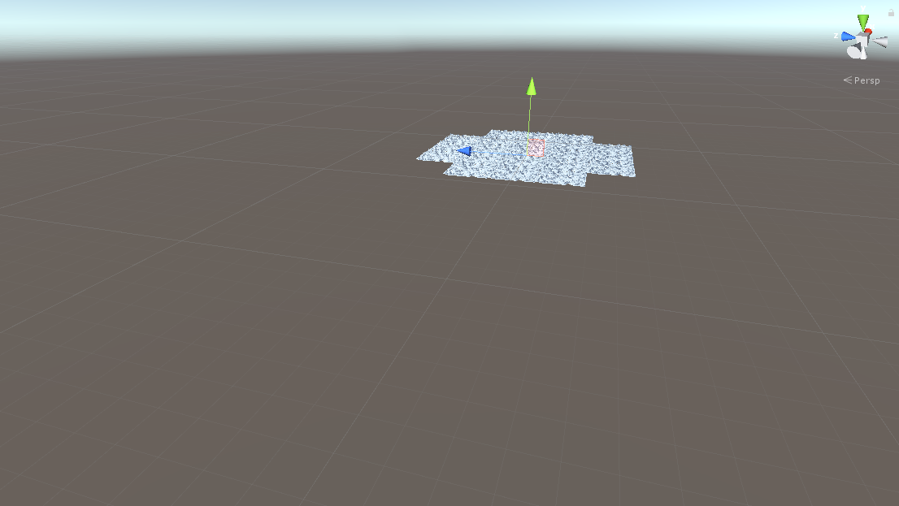

Figure : Terrain mesh chunks updating dynamically as the viewer moves

## 4.10 Endless Terrain System: Level of Detail Implementation

Before updating the terrain chunks to render textures and different meshes, the LOD system will be implemented. This means that rather than the user selecting a fixed level of detail for all terrain meshes; the project will dynamically switch the LOD of meshes based on their distance from the viewer. Meshes further from the viewer will have less vertices/triangles/detail to help improve performance.

In EndlessTerrain.cs, a new class called “LODMesh” is created. Each terrain chunk will have an array of these LODMesh’s, the class is responsible for fetching its own mesh from the map generator. The class will store variables for what the mesh is, whether the mesh has been requested and if it has the mesh. The “RequestMesh” method in the class is used to request the mesh.

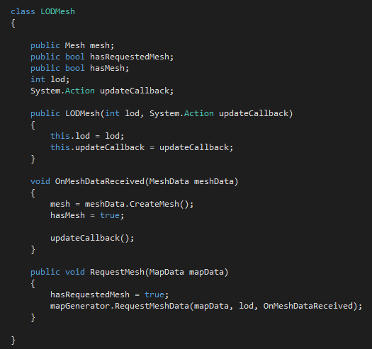

Figure : LODMesh class

The result of implementing the LOD system into the endless terrain system is that, the user can now specify how many levels of LOD are present in the endless terrain and at what distance from the viewer that LOD takes effect. Chunks further from the viewer can now be assigned to have less detail, this is a technique regularly used to significantly improve performance.

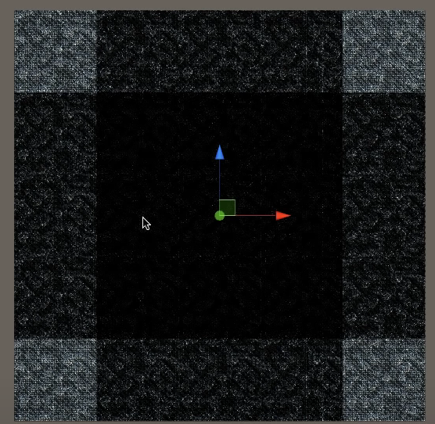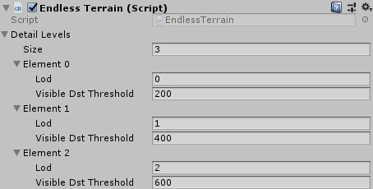

Figure : Shaded Wireframe view to show chunks further from the viewer with less triangle and vertices

## 4.11 Endless Terrain System: Textures and Mesh Offset

Now that the LOD system is working correctly, the next step is to render textures onto the terrain chunk meshes. In EndlessTerrain.cs, when the map data is received the texture will be created and applied to the material.

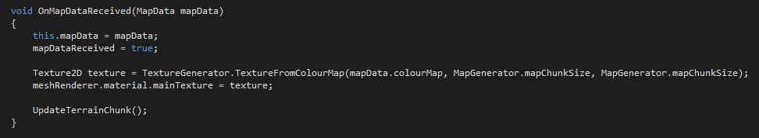

Figure : Texture created and applied to material when map data is received

It was a quick fix, but the result is that the endless terrain system now has textures rendered on the terrain chunk meshes. Also, so that the same mesh isn’t used for each chunk, a vector of centre variables is used with an offset added to it when the map data is generated.



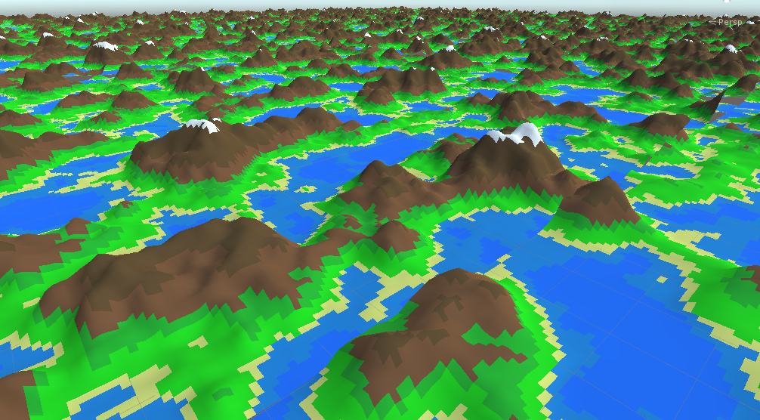

Figure : Endless Terrain rendered with textures

## 4.12 Seams

The project has come far; by generating user programmable Perlin noise it is now able to render a noise map, user programmable colour map, a textured terrain mesh, as well as an endless terrain system of textured and threaded terrain chunks with LOD implemented. It is still possible to improve the project further however, currently the terrain chunks to not align appropriately at the seams; a good improvement would be to fix this and make the terrain chunks join seamlessly and create the illusion of one continuous mesh.

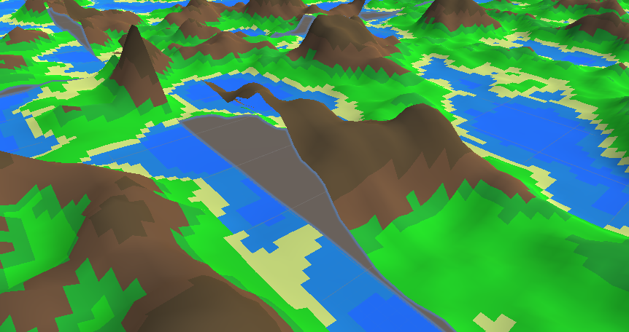

Figure : Terrain chunks with seams NOT aligned

The first step is to make it so that the octave offsets are also affected by scale and frequency; this is done in the Noise.cs script.

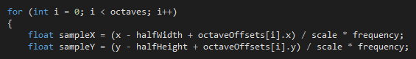

Figure : Octaves loop affected by offsets

Now, the terrain chunks align more appropriately and are more seamless.

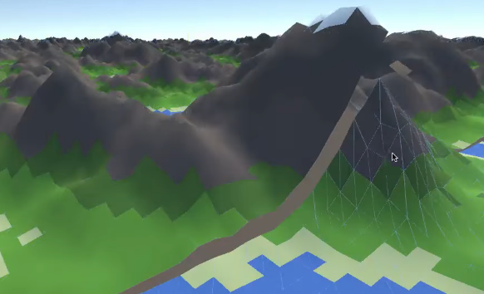

Figure : Terrain chunk seams aligned but gap still visible

It still isn’t perfect however; the terrain chunks are not lining up completely and there is a visible gap between the chunks. The reason for this is that when we normalise the map values between 0 and 1 (inside Noise.cs), minNoiseHeight and maxNoiseHeight will have slightly different values for each of the terrain chunks. This method is preferred when the project is generating a single mesh (this allows the entire range of values to be used) but since there are many meshes being generated, chunk by chunk, changes will need to be made; we will have to estimate what the minimum and maximum noise height values will be.

So that the current method can still be used for when the project is generating a single mesh; an enum called “NormalizeMode” is created in Noise.cs. This has 2 modes; “Local” will use the local minimum and maximum height values and “Global” will be used to estimate a global minimum and maximum height value. The GenerateNoiseMap method will be changed to take this new normalize mode as an argument

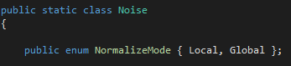

Figure : Noise class with NormalizeMode enum

An if and else statement will be used to handle cases for each mode when the height values are being calculated.

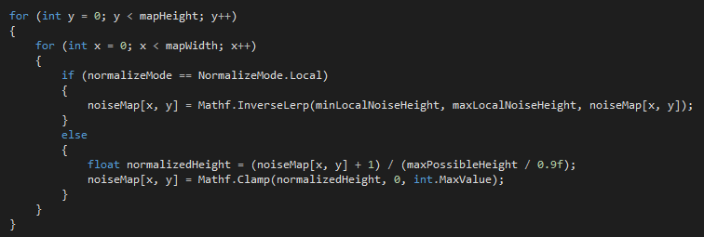

Figure : if and else statement to handle cases for each normalise mode

To begin to estimate height values for Global mode, the maximum possible height must be calculated first. Currently the noise height is calculated as the perlinValue multiplied by amplitude for each of the octaves, and every octave amplitude is being multiplied by persistence; so the maximum height value will be reached if the perlinValue is equal to 1 for every octave. Now that it is understood how the maximum possible height value is reached, a variable to store this value is declared called “maxPossibleHeight”.



Figure : maxPossibleHeight variable declared

When looping through the octaves, maxPossibleHeight is calculated.

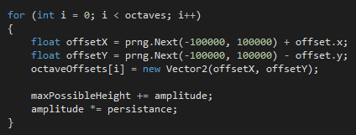

Figure : maxPossibleHeight calculated in octaves loop

The normalized height is also calculated using the maxPossibleHeight variable.



Figure : normalized height calculated

With the editor option implemented into MapGenerator.cs, the user can now set the normalize mode to either Local (best used for a single mesh) or Global (best used for the endless terrain system). When the project is set to Global, the terrain now joins together seamlessly; with no gaps visible and the illusion of a single mesh complete.

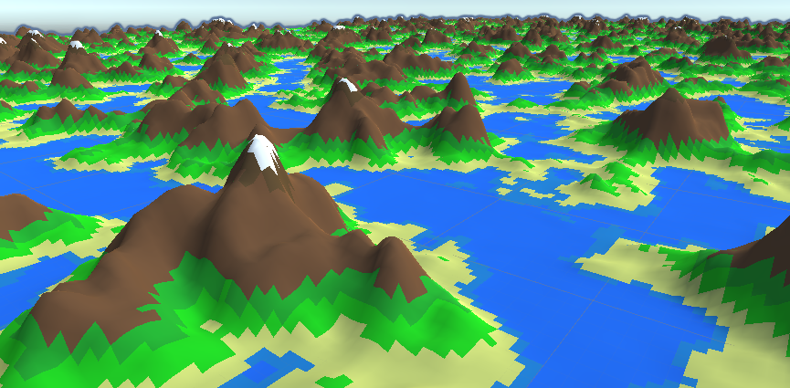

Figure : Seamless Procedurally Generated Infinite Terrain

# Chapter 5: Evaluation

## 5.1 Test Plan

Since an agile methodology was used to develop the project, features would be continually tested as they were implemented; ensuring no unexpected errors arose. However, a full test of all the features was also conducted to ensure the software was working as intended; these tests included white box tests to ensure the software works from a user point of view, as well as black box tests to ensure code is working as intended:

|  |  |  |  |
| --- | --- | --- | --- |
| Objective Tested | Test Description | Expected Results | Actual Results |
| Unity and C# used for project development | Have I met my original aim of using Unity and C#, tools I was unexperienced with, to fully develop this project | Unity and C# used to develop software product | As expected |
| Generate Perlin noise map | Has a method for generating a Perlin noise map been implemented into the project | C# scripts have been used to implement a Perlin noise map generation method | As expected |
| Greater Perlin noise map control | Using the editor, the octaves, lacunarity, persistence, seed, offset and noise scale values were changed | The noise map will update appropriately as the user changes these values | As expected |
| Perlin noise map rendered to screen | The generate button in the editor is pressed | When told to by the user, the noise map will render as a texture to the screen | As expected |
| Generate colour map | Using the editor the map generator is set to colour mode (with map values set in the editor) | A colour map texture renders to the screen, it appropriately represents the values the user inputs | As expected |
| User can use editor to choose regions and colours of colour map | A number of regions, height values and colours are set using the editor | The regions and colours set by the user are appropriately rendered | As expected |
| Textured 3D mesh rendered using noise map | Using the editor, the map generator is set to Mesh mode | A textured 3D mesh is generated using the noise map and rendered as a 3D representation | As expected |
| Chunks of terrain rendered around viewer and update dynamically as the viewer moves | When in play mode, the viewer object is moved along the x and z axis | As the viewer moves, chunks that are within visual distance of the viewer will dynamically render and chunks outside of this distance will not render | As expected |
| Endless terrain uses LOD to improve performance | When in play mode, the camera is manoeuvred to inspect the chunks | Chunks that are further from the viewer will have less vertices, triangles and details; chunks closer to the viewer will be more detailed | As expected |
| Endless terrain is textured | Press play | When terrain chunks are rendered, they use the colour map and are textured | As expected |
| Endless terrain utilises threading to improve performance | Press play | Threading technique works as expected and the project does not freeze up as chunks are rendered | As expected |
| Terrain chunk vertices align appropriately, to create the illusion of a single continuous mesh (seamless chunks) | Press play and inspect seams between terrain chunks | The endless terrain system appears to be a single continuous mesh, with vertices correctly aligned along the seams and no gaps visible between chunks | As expected |

## 5.2 Objectives Completed? Aim Accomplished?

Every objective outlined in this report was fully completed, that means I can confidently say that the project aim was accomplished. A noise algorithm has been used to generate both a 3D terrain mesh and an infinite and seamless 3D landscape, along with this the noise map and colour map can be rendered as a visual texture representation.

## 5.3 Project Strengths and Significance

### 5.3.1 Project Management

This project was managed extremely well, the agile development methodology used was a perfect fit. It ensured that every task was completed by its deadline and by testing every feature/developing incrementally; few errors arose. I have attended a monthly meeting with my supervisor for every month since the start of the project; here we would review the work completed in the previous month and set tasks to be completed for the next month. Additional weekly meetings were also utilised for continuous feedback, as well as regular contact by email. Work has been completed regularly and on time since the start of the project timeline, all tasks were completed by their assigned deadline.

### 5.3.2 Project Difficulty and Learning

This is by far the most ambitious project I have ever undertaken, to complete the project I had to learn to use a new engine, a new programming language and I also had to research an area I had very little experience with. This greater difficulty only served to encourage me however, and I have now learnt a new engine, language and development area. I have also proved to myself and employers that I am an exceptional independent learner, an excellent skill to possess as a programmer and games developer.

## 5.4 Project Weaknesses

Since the project has been a total success, there are few weaknesses to note. The biggest weakness is likely that the software product can not be used in a finished game project; it is more of a tech demo/fun application, the project would have to be expanded further if the terrain generated were to be used in a finished game.

# Chapter 6: Conclusions & Further Work

To conclude, I have learnt **a lot** from this project. I am now an experienced Unity and C# developer and I also know much, much more about noise algorithms and the techniques and research behind infinite and procedural generation. I am extremely happy with the result of this project; I was initially worried I wouldn’t be able to complete all of my objectives but effective project management meant I could. The project is an impressive tech demo (for me) but is doesn’t have much realistic use as it is not ready for use in games. There are a number of ways this project could be expanded for use in games; such as implementing erosion algorithms, mesh collision, shaders and gameplay mechanics (e.g. player character).

# References & Bibliography

Archer, T. (n.d.). *Procedurally Generating Terrain.* Sioux City, Iowa: Morningside College.

Brackeys. (2017, May 24). *Generating Terrain in Unity*. Retrieved from https://www.youtube.com/watch?v=vFvwyu_ZKfU

Brackeys. (2017, May 17). *Perlin Noise in Unity*. Retrieved from https://www.youtube.com/watch?v=bG0uEXV6aHQ

Daniel Michelon De Carli, F. B. (2011). *A Survey of Procedural Content Generation Techniques Suitable to Game Development.* Games and Digital Entertainment (SBGAMES).

freeCodeCamp.org. (2018). *C# Tutorial - Full Course for Beginners*. Retrieved from https://www.youtube.com/watch?v=GhQdlIFylQ8

Holistic3d. (2018, May 26). *The Theory of Noise: An Overview of Perlin Noise*. Retrieved from https://www.youtube.com/watch?v=H6FhG9VKhJg

Joel Spolsky, M. P. (2020). Retrieved from Trello: https://trello.com/

Mark Hendrikx, S. M. (2013). *Procedural Content Generation for Games: A Survey.* Association for Computing Machinery.

Patricio Gonzale Vivo, J. L. (n.d.). *The Book of Shaders.*

R.M. Smelik, T. T. (2008). *A Proposal for a Procedural Terrain Modelling Framework.*

Refsnes Data. (2020). *C# Tutorial*. Retrieved from w3schools: https://www.w3schools.com/cs/

Roland van der Linden, R. L. (2014). Procedural Generation of Dungeons. *IEEE Transactions on Computational Intelligence and AI in Games*.

Sepp, A. (2015). *Procedural Infinite Terrain Generation with Noise Algorithms.*

Skeet, J. (2008). *C# in Depth.*

Statista. (2020). *Cumulative number of copies of Minecraft sold worldwilde as of May 2019*. Retrieved from https://www.statista.com/statistics/680124/minecraft-unit-sales-worldwide/

Unity Technologies. (2020). Retrieved from Unity: https://unity.com/

Unity Technologies. (2020). *Unity Learn*. Retrieved from Unity: https://unity.com/learn

Uzility. (2014, July 26). *Introduction to Scrum*. Retrieved from https://www.youtube.com/watch?v=9TycLR0TqFA

# Appendices

## Application Code

### Noise.cs

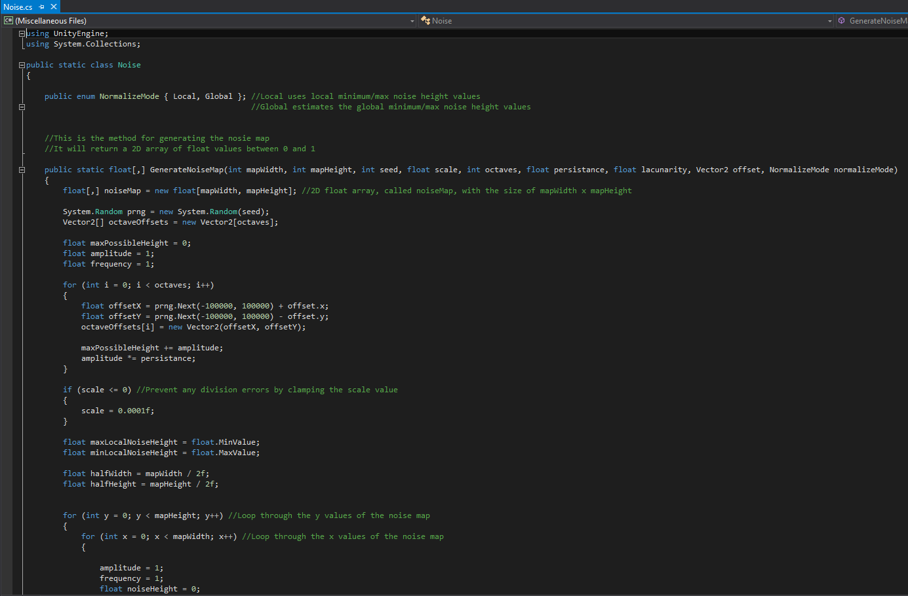

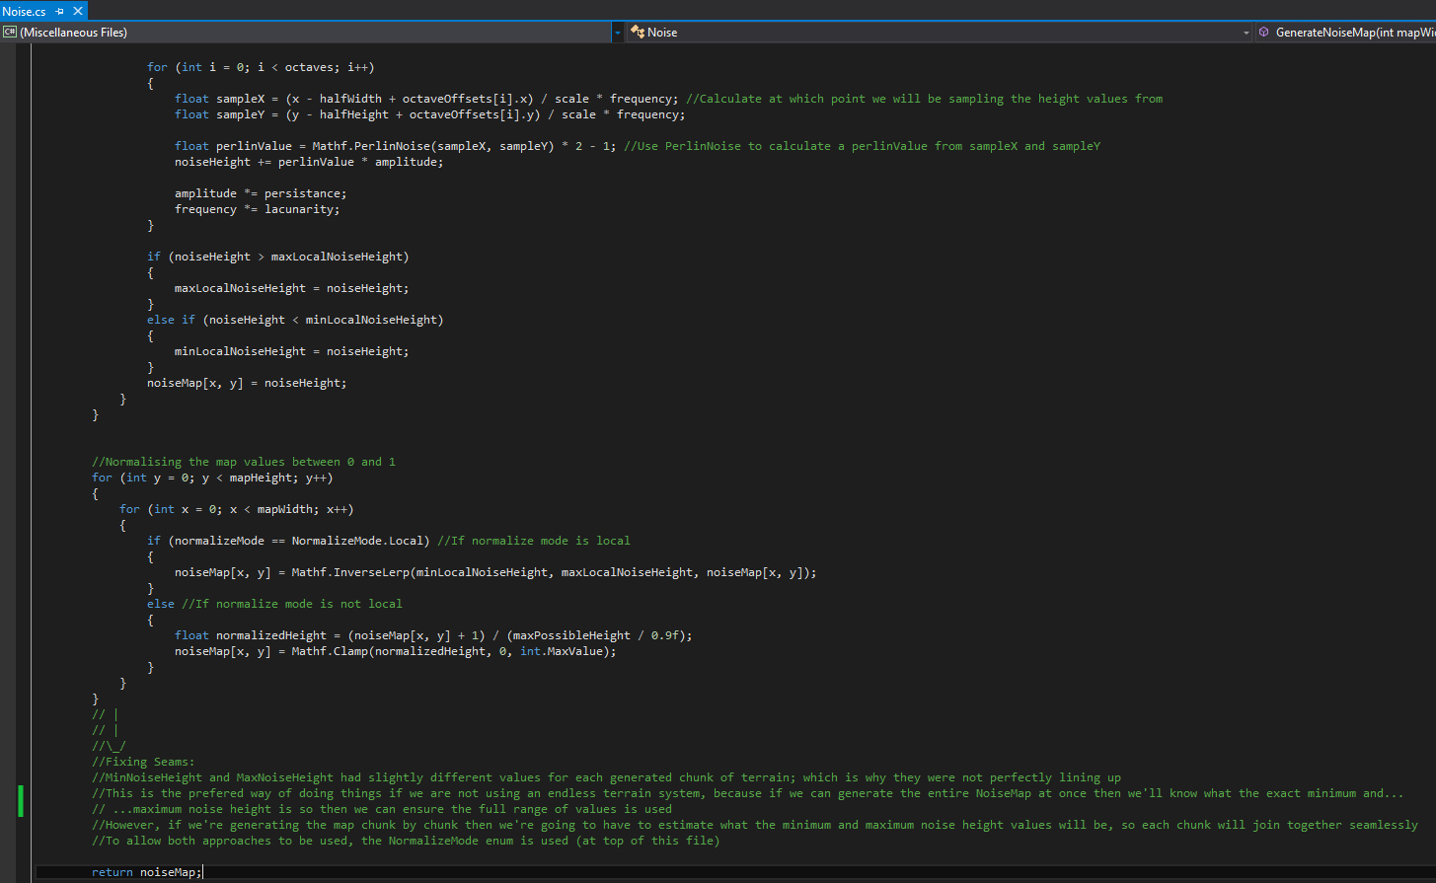

### MapGenerator.cs

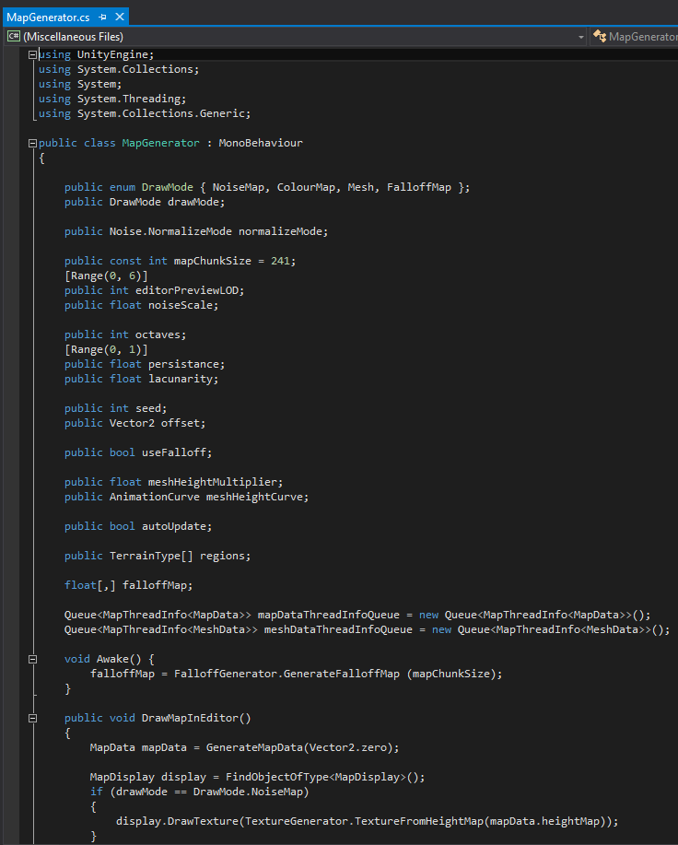

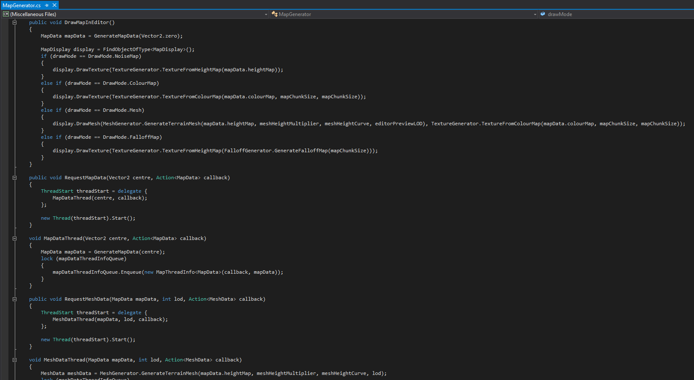

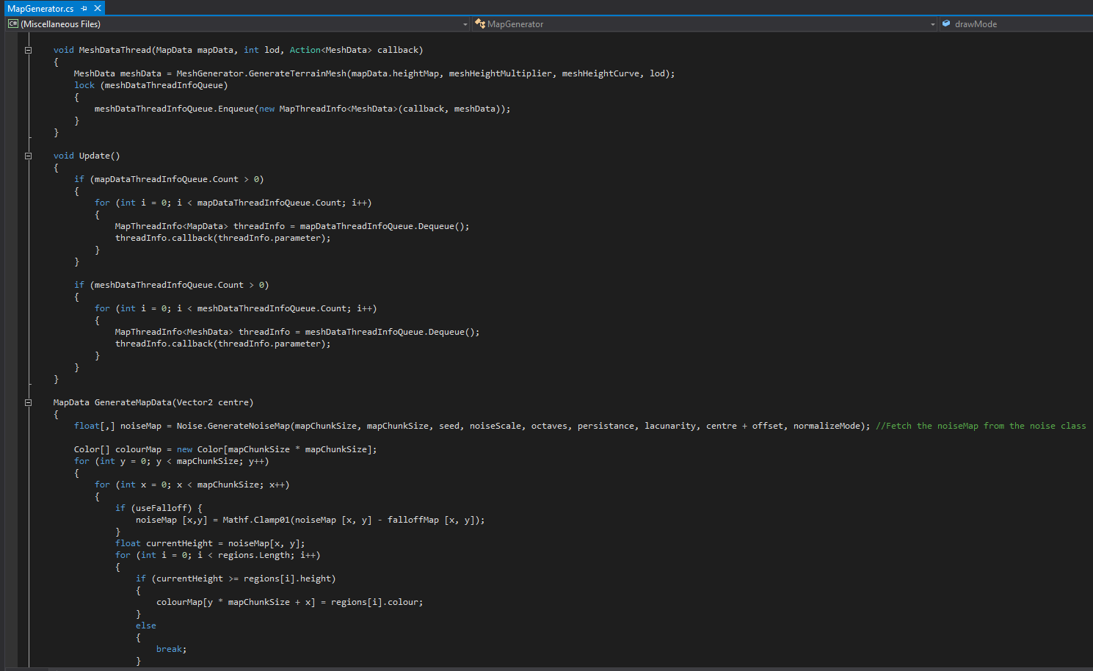

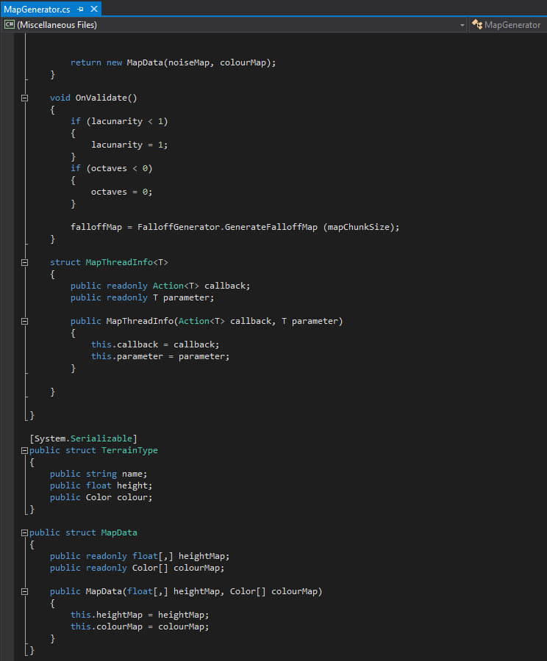

### MeshGenerator.cs

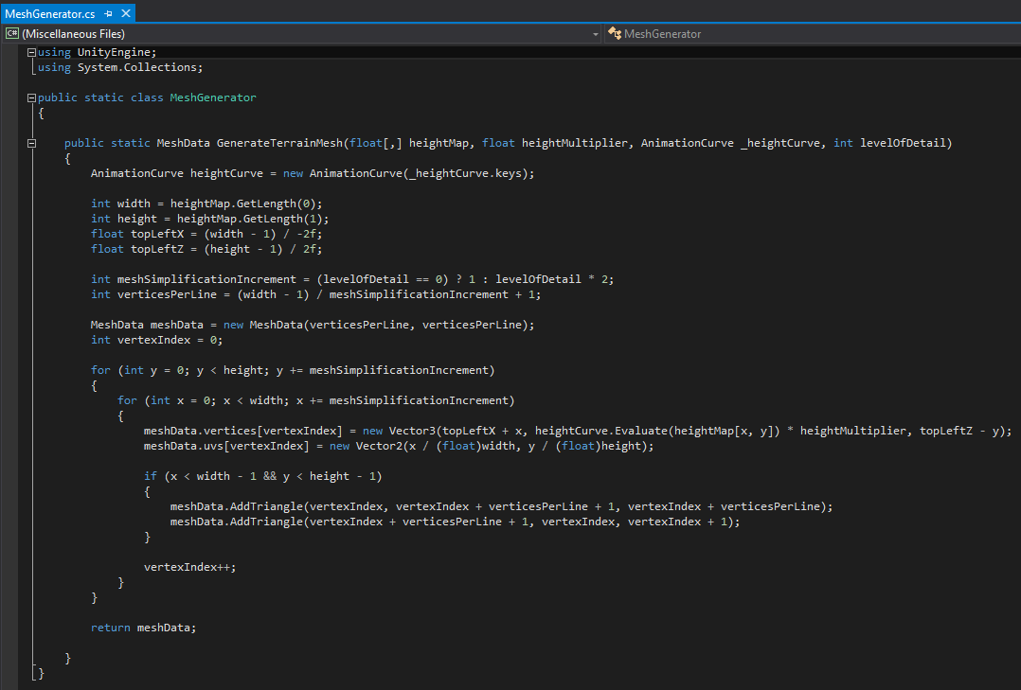

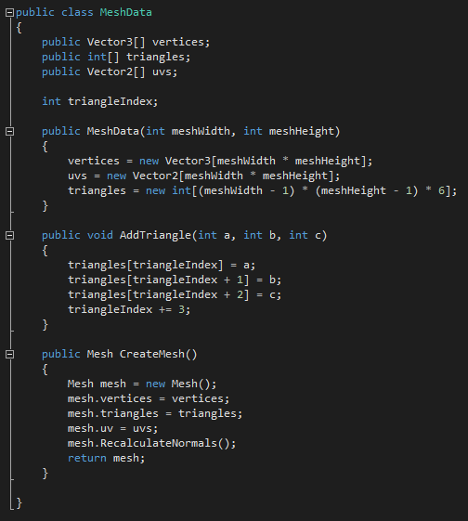

### MapDisplay.cs

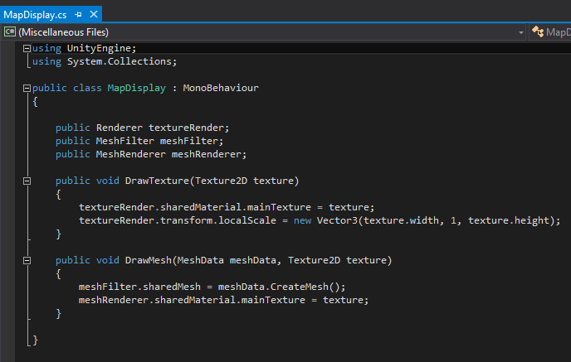

### TextureGenerator.cs

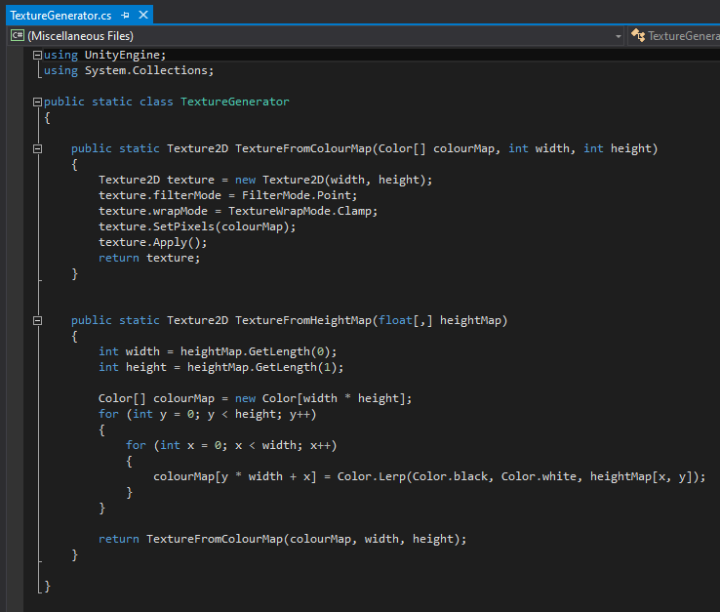

### EndlessTerrain.cs

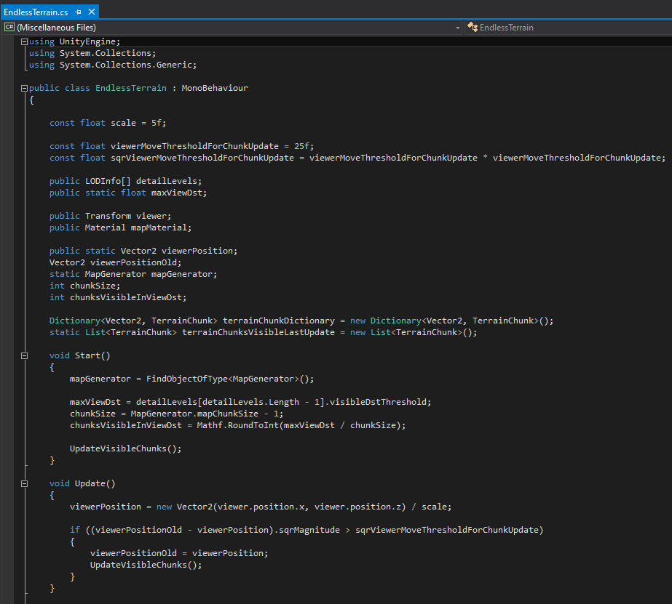

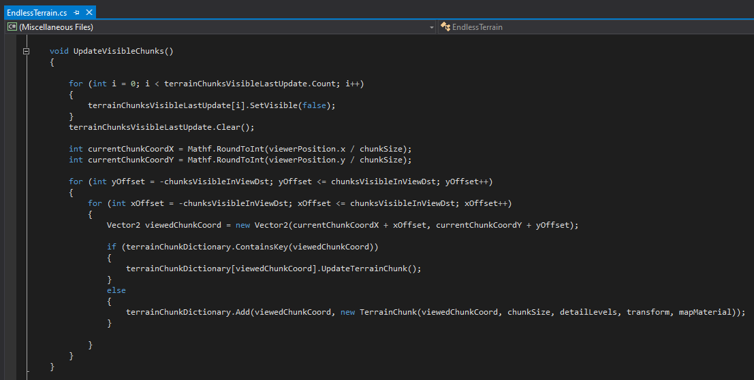

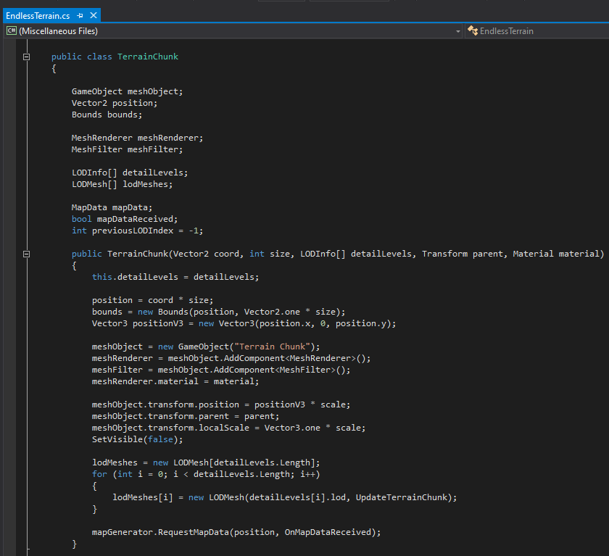

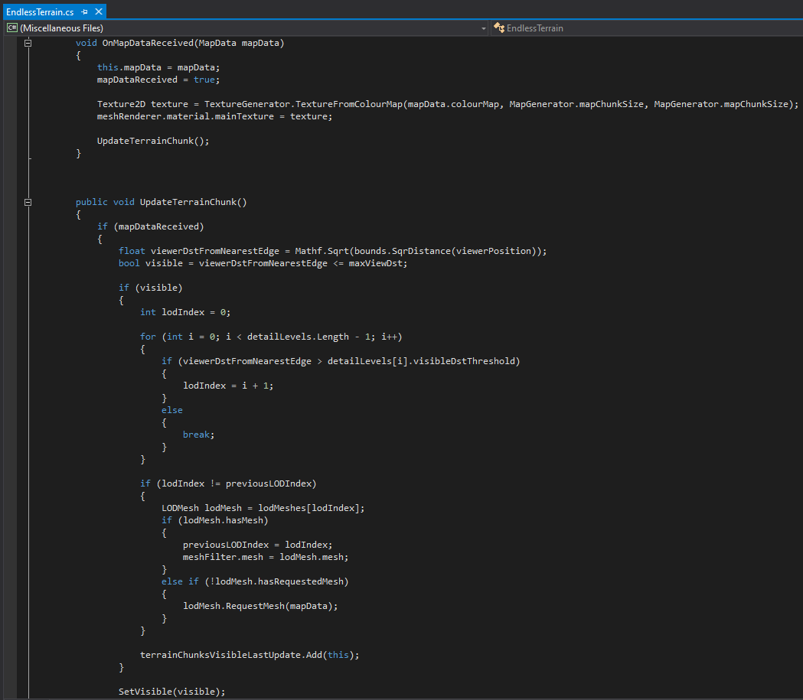

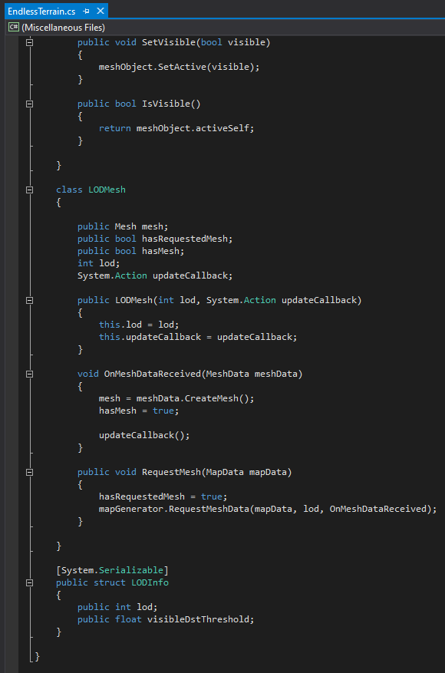

### FalloffGenerator.cs

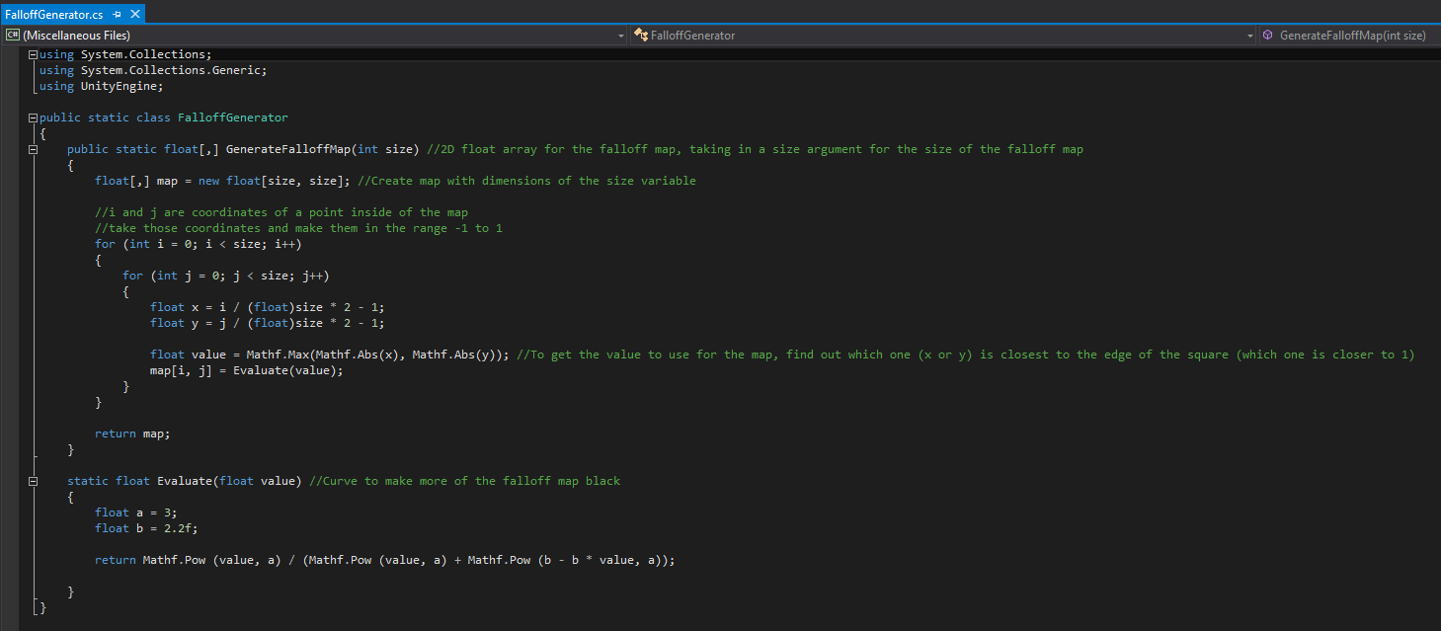

## Monthly Reports

### November Supervision Meeting Report



### December Supervision Meeting Report



### January Supervision Meeting Report

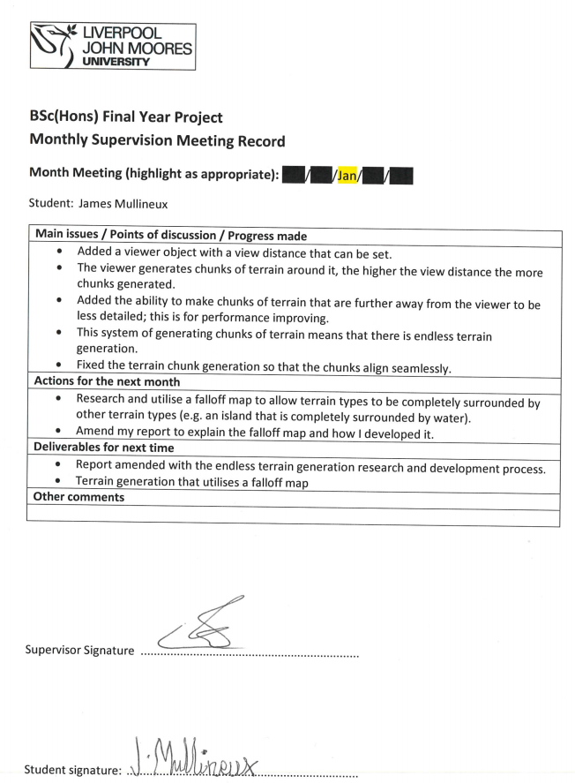

### February Supervision Meeting Report



### March Supervision Meeting Report



### April Supervision Meeting Report



## Ethics Application and Approval Documentation





**END OF DOCUMENT**